

Capstone Project Report
Report 6 – Software User Guides

– Ho Chi Minh, December 2024 –
Table of Contents
I. Record of Changes 3
II. Release Package & User Guides 4
1. Deliverable Package 4
2. Installation Guides 4
2.1 System Requirements 4
2.2 Installation Instruction 4
3. User Manual 7
3.1 Overview 7
3.2 Register Flow 7
3.3 Process Order Flow 12
3.4 Process Support Ticket Flow 27
3.5 Feedback Flow 33

I. Record of Changes
Date | A*  M, D | In charge | Change Description
30/11/2024 | A | QuocLNH,  NgocPD,  ThaoHTP | Add Deliverable Package, Installation Guides, User Manual.
12/12/2024 | M | QuocLNH | Update Installation Guides, User Manual.
*A - Added M - Modified D - Deleted

II. Release Package & User Guides

1. Deliverable Package
No. | Deliverable Item | Description
01 | Project Backlog | FA24SE026_TranNgocNhuQuynh_Backlog.xlsx
02 | Source Codes | Frontend: FA24SE026_TranNgocNhuQuynh_FE.zip  Backend: FA24SE026_TranNgocNhuQuynh_ BE.zip
03 | Database Script(s) | FA24SE026_TranNgocNhuQuynh_ DatabaseScript.sql  FA24SE026_TranNgocNhuQuynh_ DataScript.sql
04 | Final Report Document | FA24SE026_TranNgocNhuQuynh_FinalReport.docx
05 | Test Cases Document | FA24SE026_TranNgocNhuQuynh_TestReport.xlsx  FA24SE026_TranNgocNhuQuynh_UnitTest.xlsx
06 | Slide | FA24SE026_TranNgocNhuQuynh_Silde.ppt

2. Installation Guides

2.1 System Requirements

2.1.1 Hardware Requirements
PC | Minimum | Maximum
Internet connection | Cable, Wi-fi | Cable, Wi-fi
Processor | Intel Core i5 | Intel Core i7
Memory | 8GB RAM | 16GB RAM
Storage | HDD 256GB | SSD 256GB
Web Browser | Google Chrome  Microsoft Edge | Google Chrome v131.0.6778.103  Microsoft Edge v131.0.2903.86

2.1.2 Software requirements
Component | Name And Version | Description
Operating System | Windows 10 | Operating system for building production
DBMS | SQLServer 2022 | Used to manage database
.NET | .NET SDK 8.0,  .NET Core 8.0 Runtime | Use to run back-end server
ReactJS | ReactJS 18.3.1 | Use to run front-end server
IDE | Visual Studio 2022,  Visual Studio Code | Use to write, edit and run code

2.2 Installation Instruction

2.2.1 Setup Frontend Website Application
- Install Visual Studio Code by following guidelines link: https://code.visualstudio.com/docs/setup/windows
- Install npm through Visual Studio Code or you can install npm via NodeJS: https://nodejs.org/en/
- Clone the FE source code: git clone https://github.com/ngocpd2001/ShoeCareHub_FE
- Open git bash and enter:
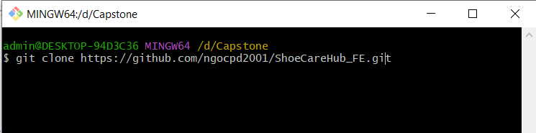
- Open terminal in visual studio:
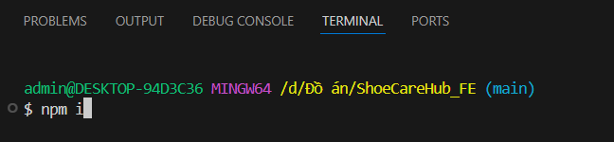
- Open terminal in visual studio to start:
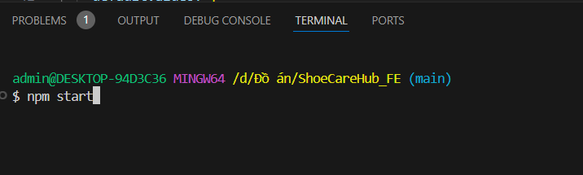

2.2.3 Setup Database
- Install SQL Server 2022 by following Microsoft guidelines: https://learn.microsoft.com/en-us/sql/database-engine/install-windows/install-sql-server?view=sql-server-ver16

2.2.3 Setup Backend Website Application
- Install Visual Studio 2022 by following guidelines link: https://visualstudio.microsoft.com/downloads/
- Clone the source code: git clone https://github.com/SEP490-TP4SCS/TP4SCS.BE.git
- Open TP4SCS.Solution.sln file with Visual Studio 2022:
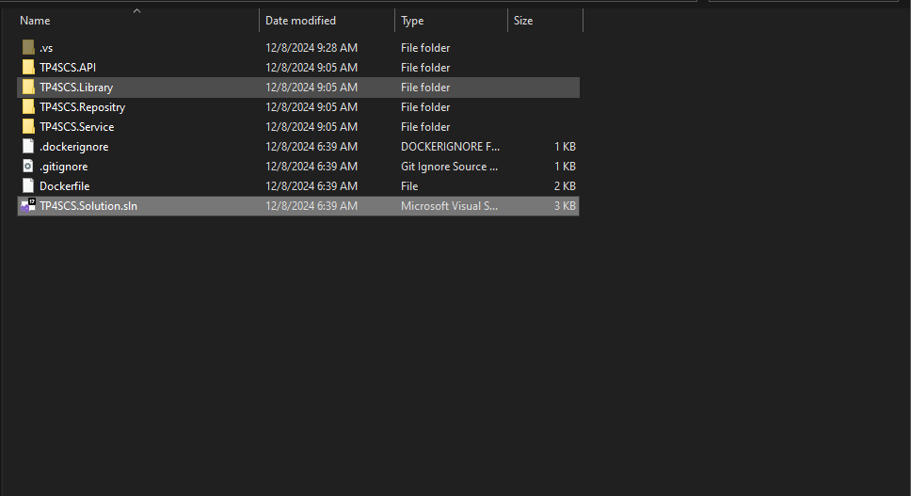
- Test the source code by click the green outline triangle to run:
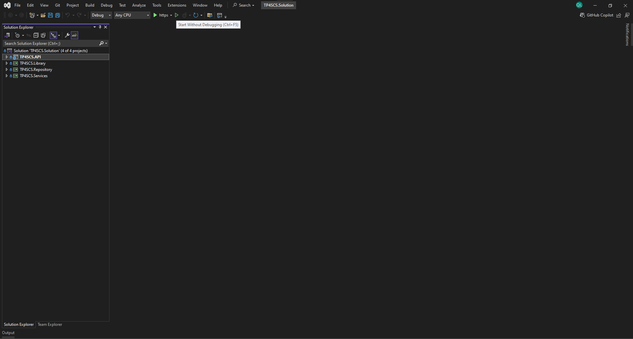

3. User Manual

3.1 Overview
ShoeCareHub is a platform that connect between those shoe service provider and customer. At customer web application, it provides feature such as: manage personal information, view service, service feedback, business ranking, order service, … At business web application, it provides feature such as: manage business, manage branch and employee, manage order, view feedback, …
With this project we have 4 main workflows:
No. | Workflow | Actor
01 | Register | Guest
02 | Process Order | Customer, Owner, Employee
03 | Process Support Ticket | Customer, Owner, Employee, Moderator
04 | Feedback | Customer, Owner, Employee, Moderator

3.2 Register Flow

3.2.1 Customer Register Flow
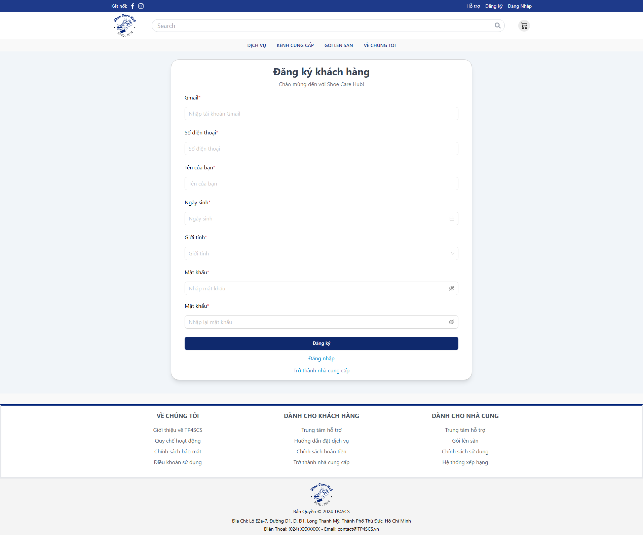
- At Login Page, click “Đăng ký”.
- Fill all require fields with valid data.
- Click “Đăng ký”.
- Check your registered email.
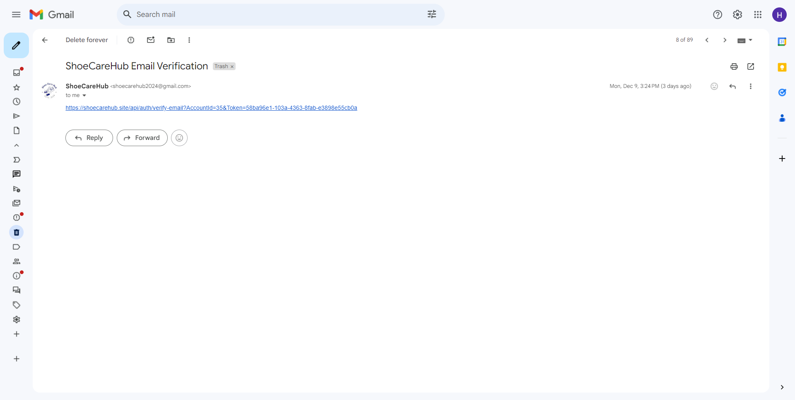
- Click on the given link

3.2.2 Owner Register Flow
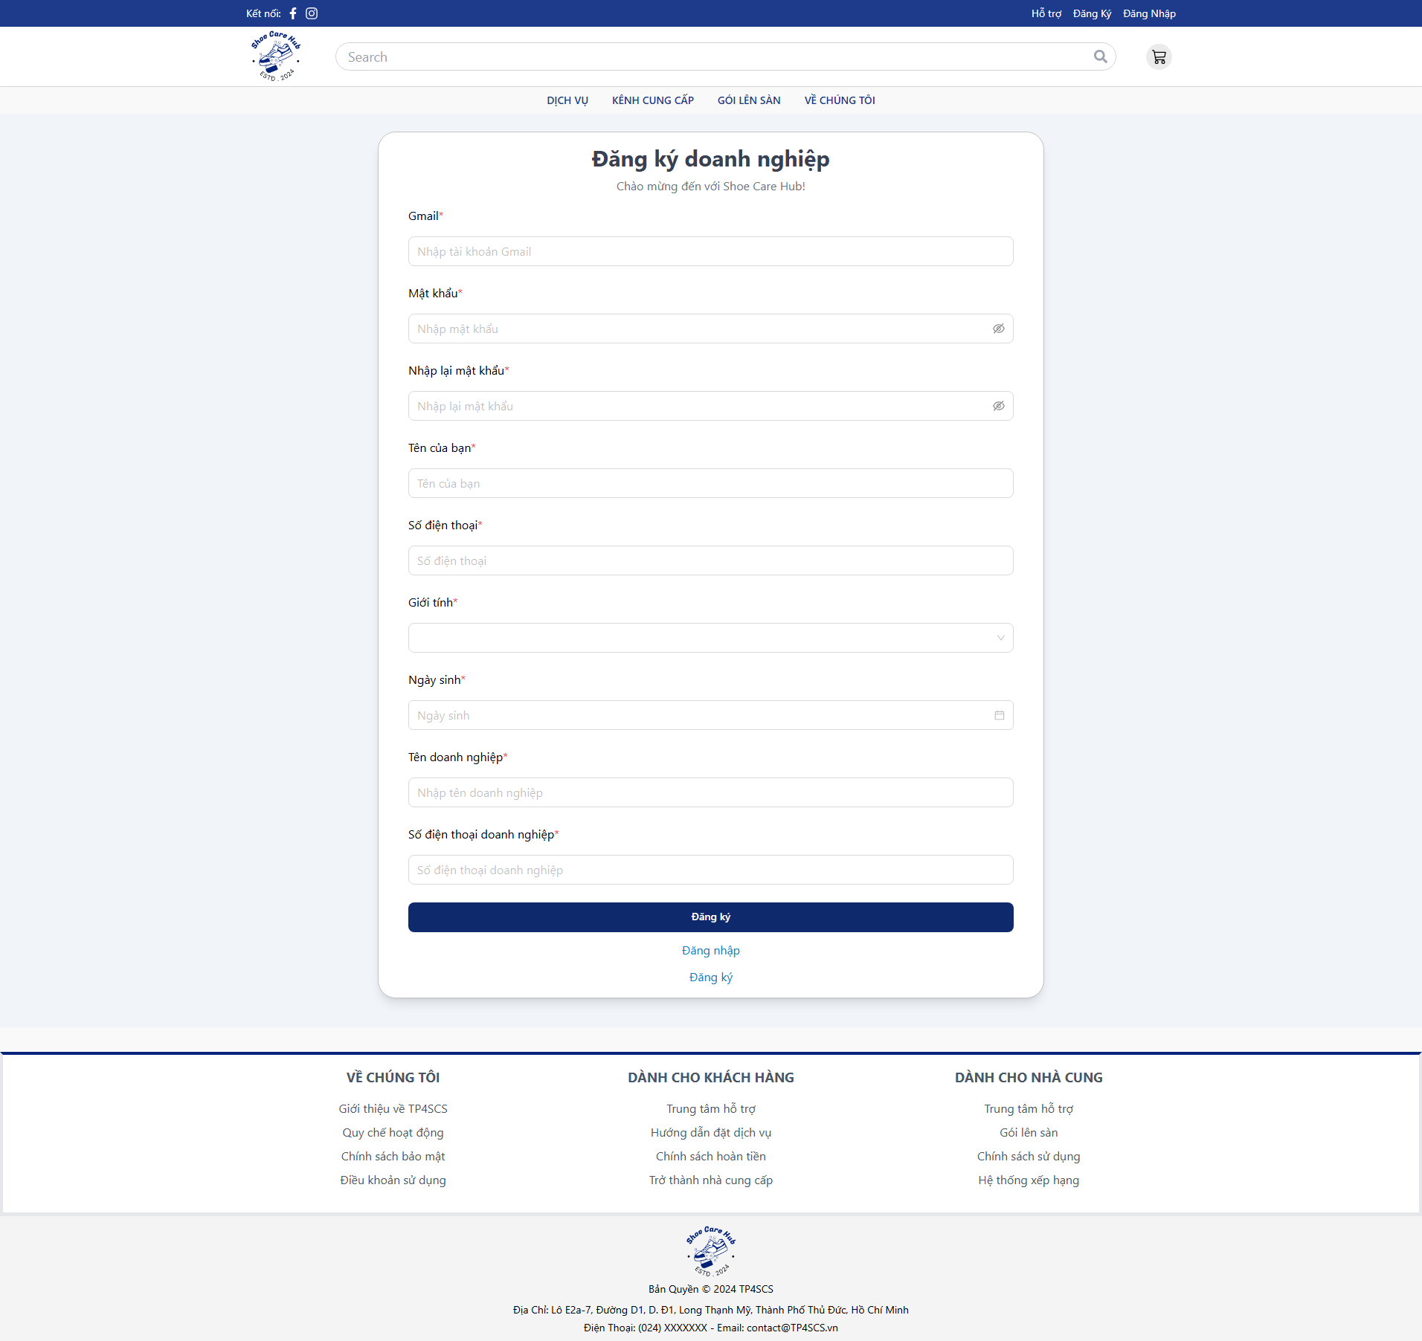
- At Login Page, click “Trở thành nhà cung”.
- Fill all require fields with valid data.
- Click “Đăng ký”.
- Check your registered email.

- Click on the given link
- Login to registered owner account.
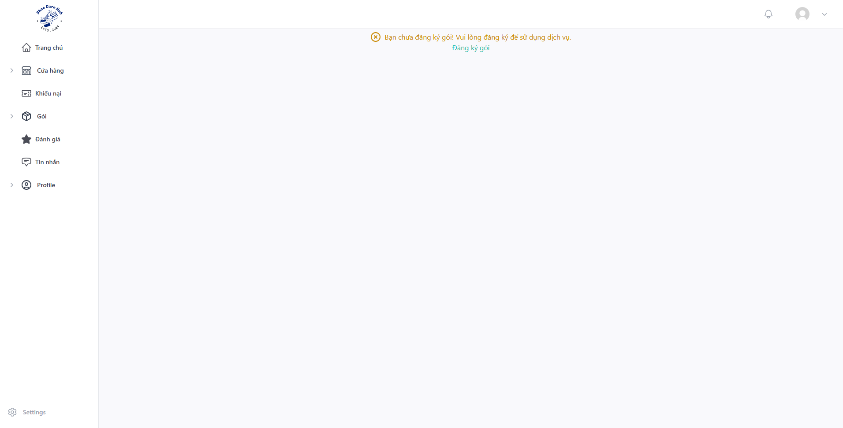
- Click “Đăng ký gói”
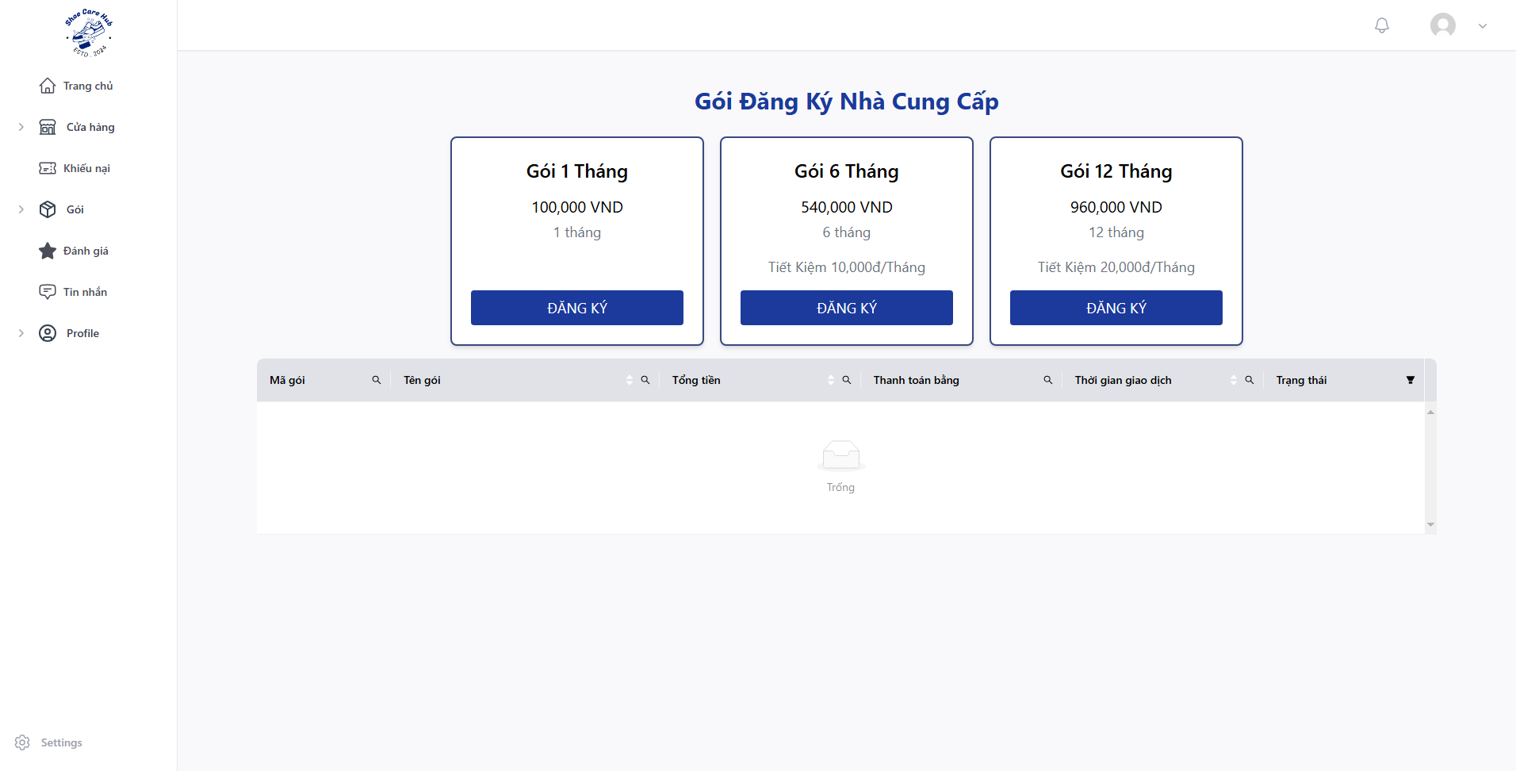
- Choose pack that you want to use and click “ĐĂNG KÝ”.
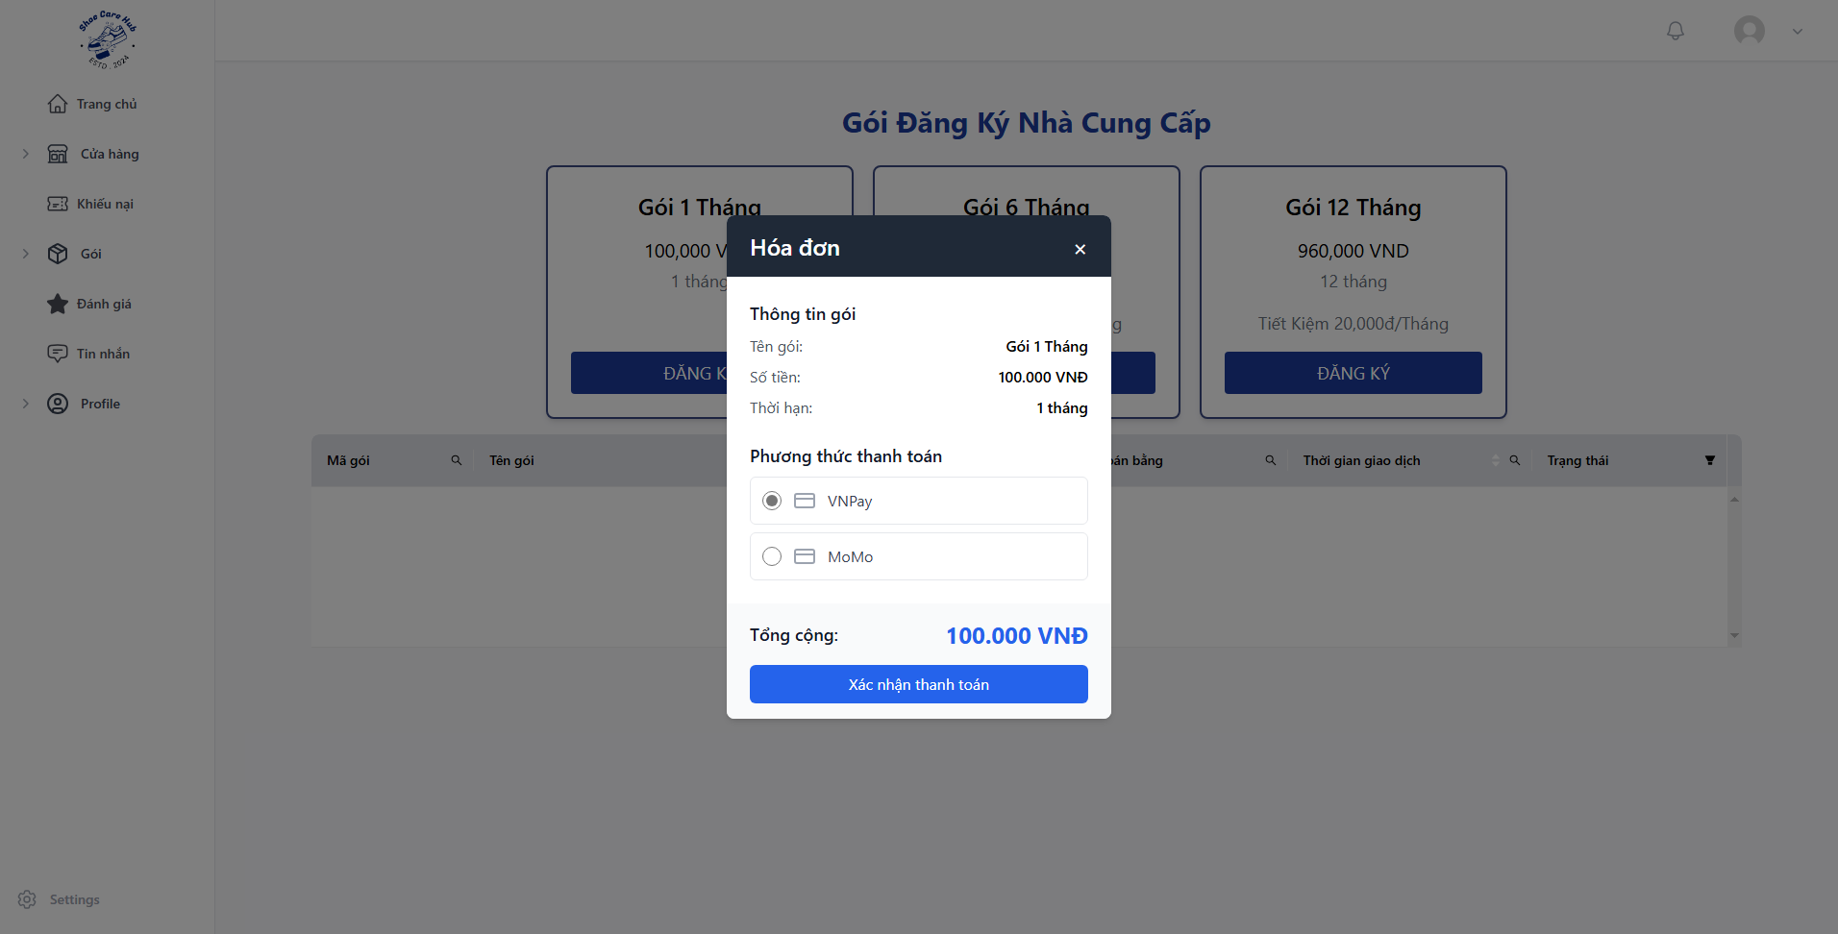
- Choose payment method and click “Xác nhận thanh toán”.
- Process payment with your VnPay or MoMo account.

3.3 Process Order Flow

3.3.1 Owner Create Service
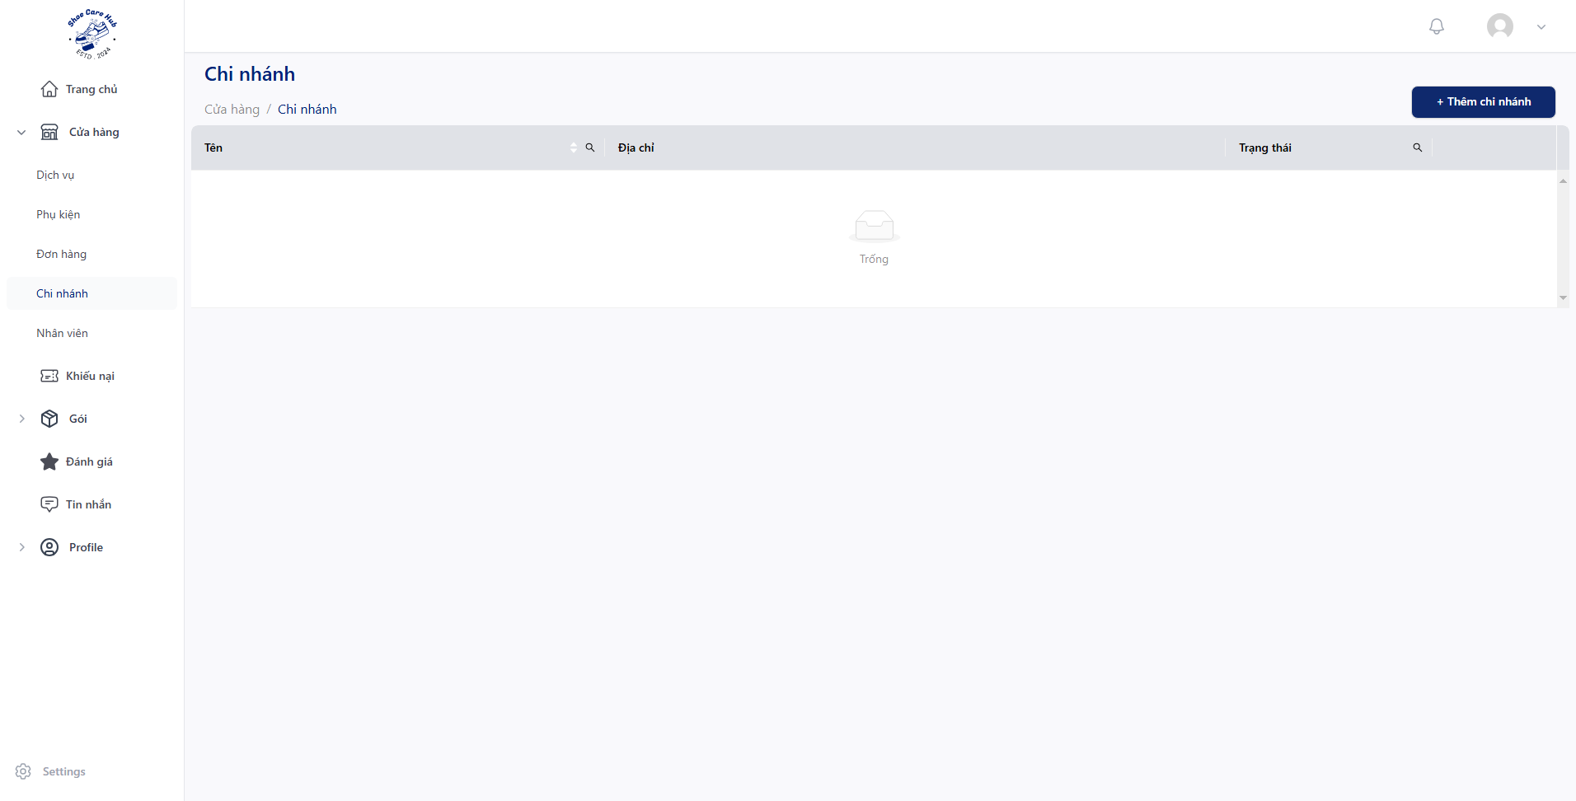
- Click “Cửa hàng” then click “Chi nhánh” and click “Thêm chi nhánh”.
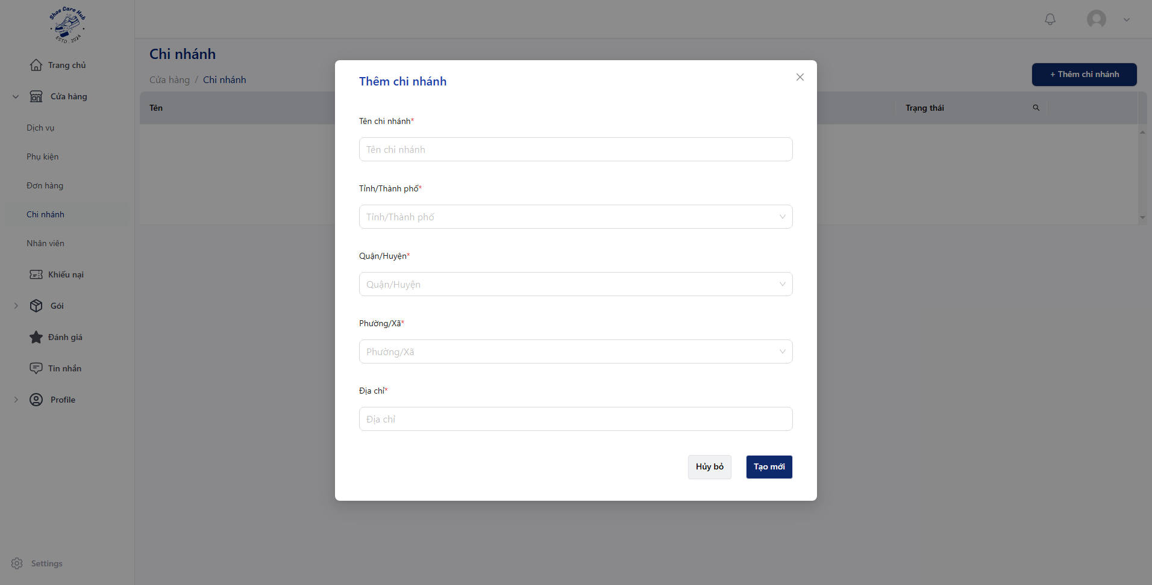
- Fill all require fields with valid data and then click “Tạo mới”.
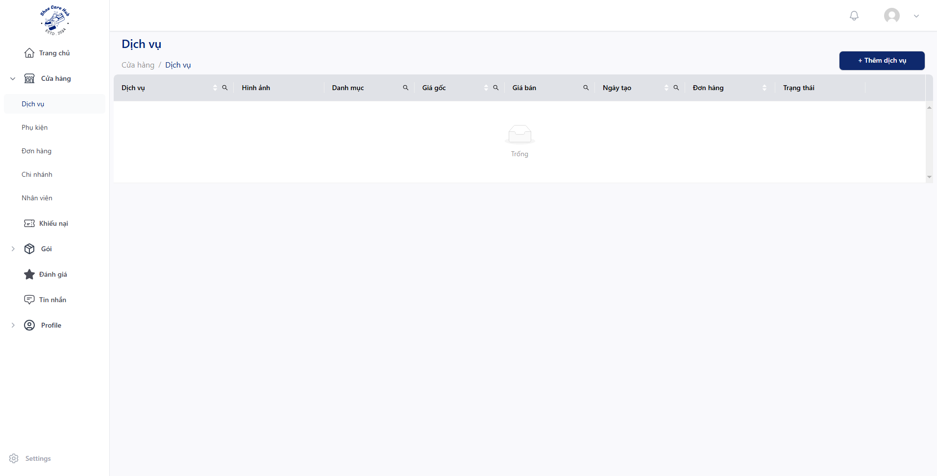
- Click “Cửa hàng” then click “Dịch vụ” and click “Thêm dịch vụ”.
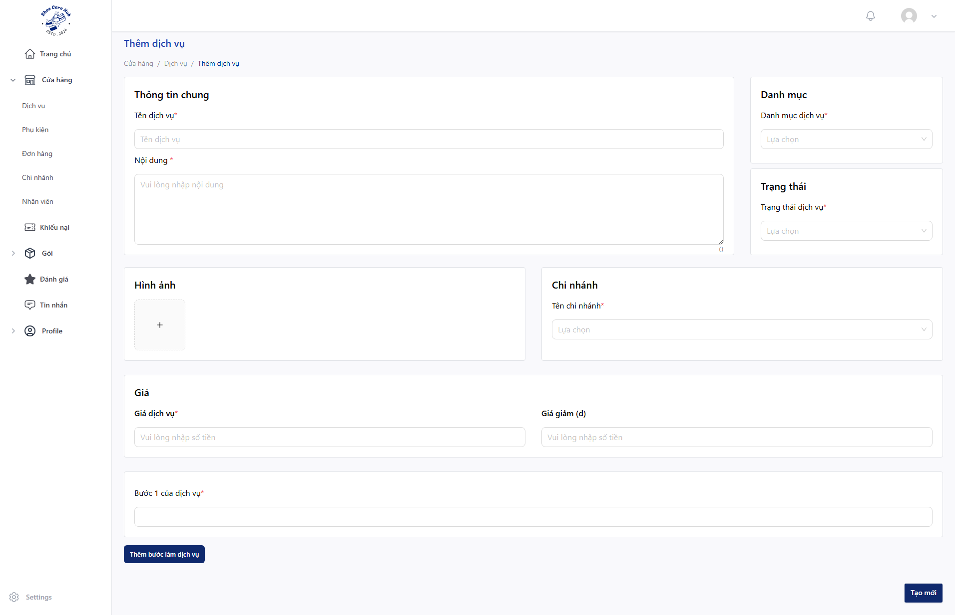
- Fill all require fields with valid data and then click “Tạo mới”.

3.3.2 Customer Order Service
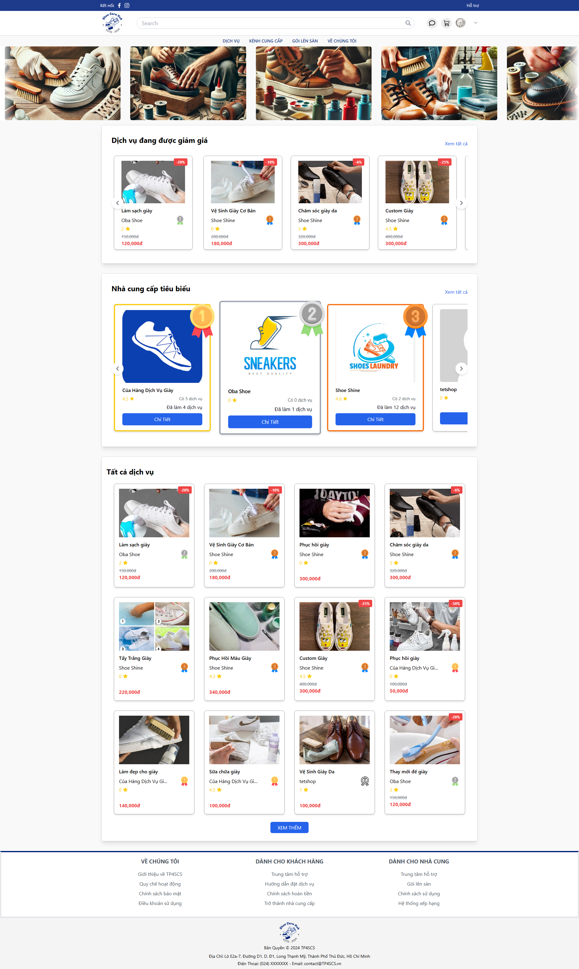
- At Home Page, click on any service you want.

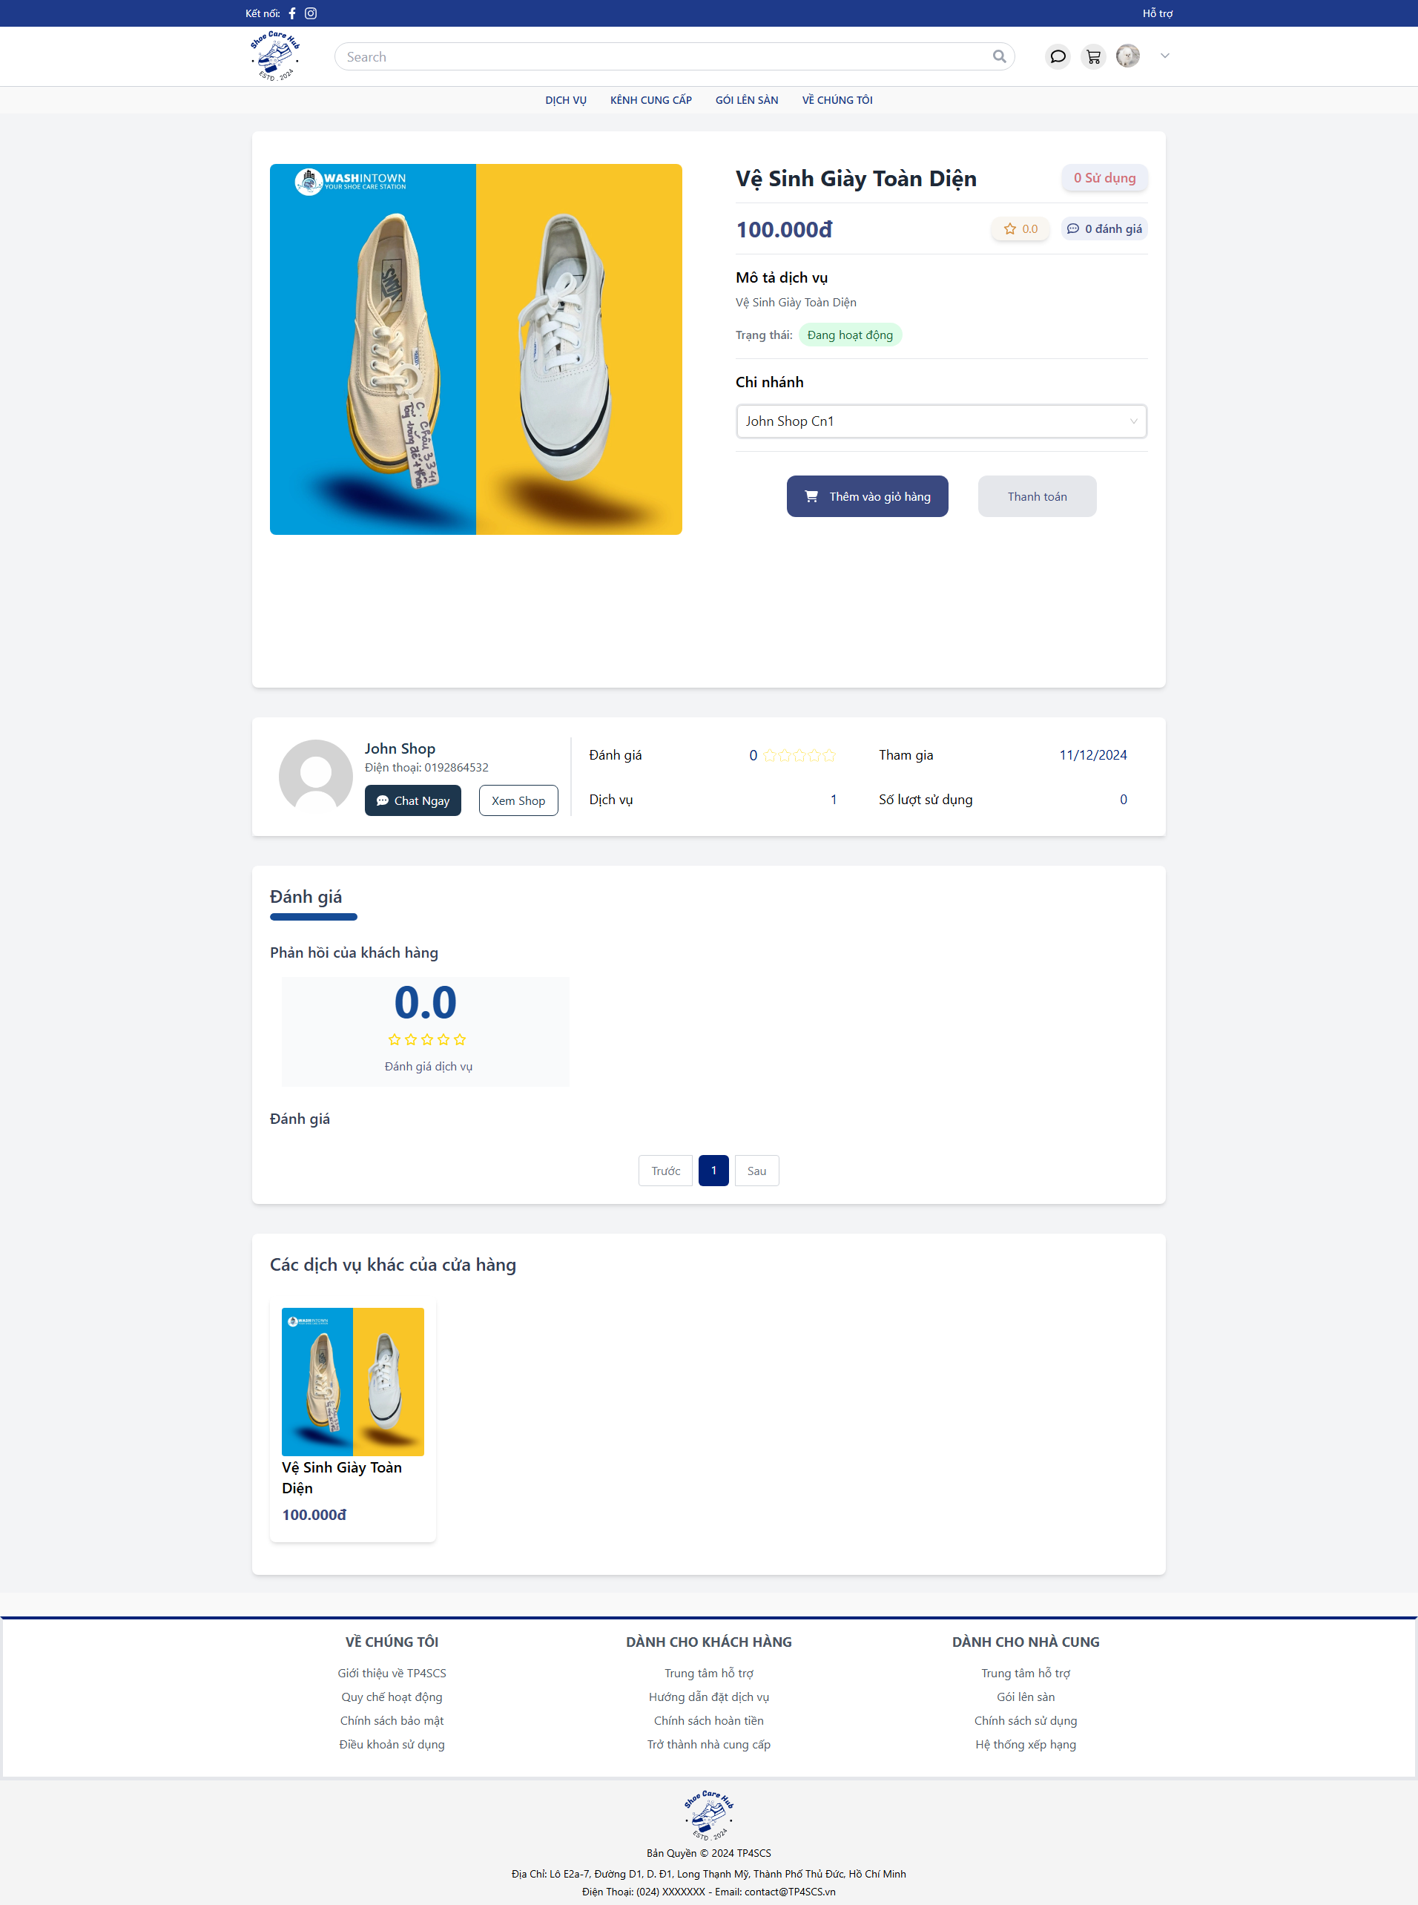
- Choose the branch you want and click “Thanh toán”.

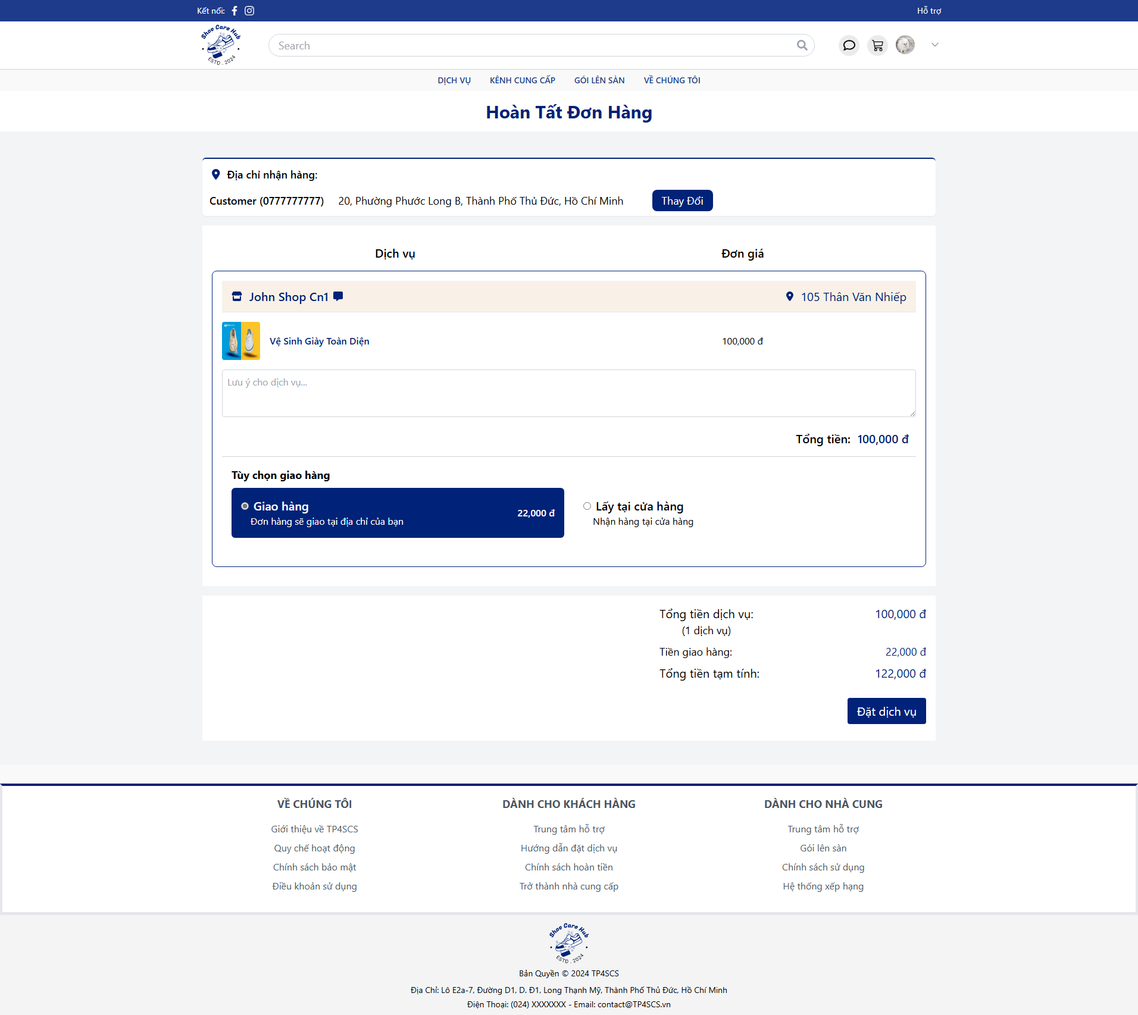
- Choose your created address by clicking “Thay Đổi”.
- Choose ship method you want by click on “Giao hàng” or “Lấy tại cửa hàng”.
- Click “Đặt dịch vụ”.

3.3.3 Owner Process Service
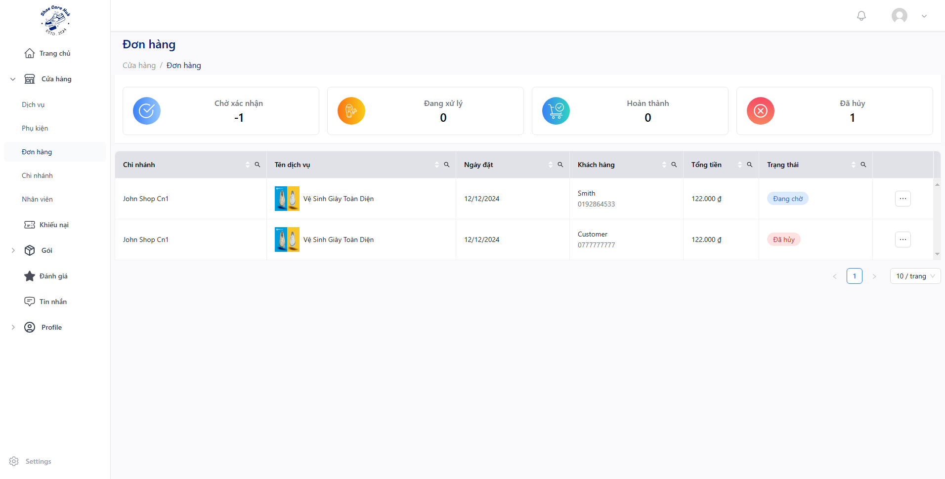
- Click “Cửa hàng” then click “Đơn hàng” and click “”.
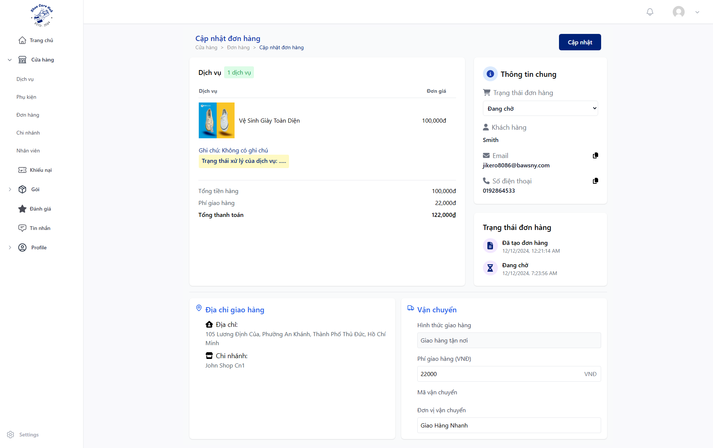
- Click “Trạng thái đơn hàng” and choose “Đã xác nhận” to process order or “Đã huỷ” to cancel the order and click “Đồng ý” then “Cập nhập”.
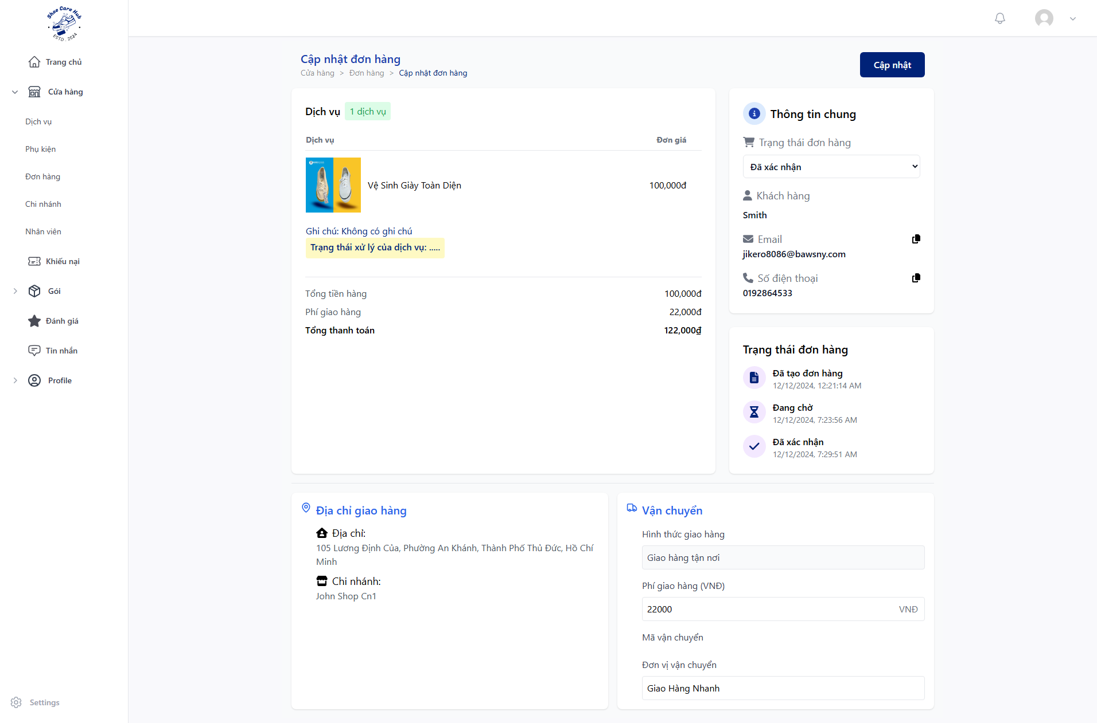
- Click “Trạng thái đơn hàng” and choose “Đã nhận” and click “Đồng ý” then “Cập nhập”.
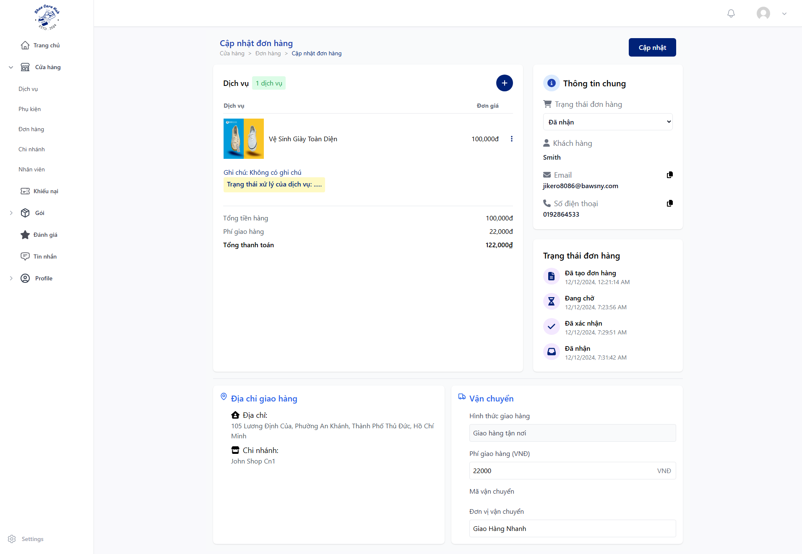
- Click “Trạng thái đơn hàng” and choose “Đang xử lý” and click “Đồng ý” then “Cập nhập”.
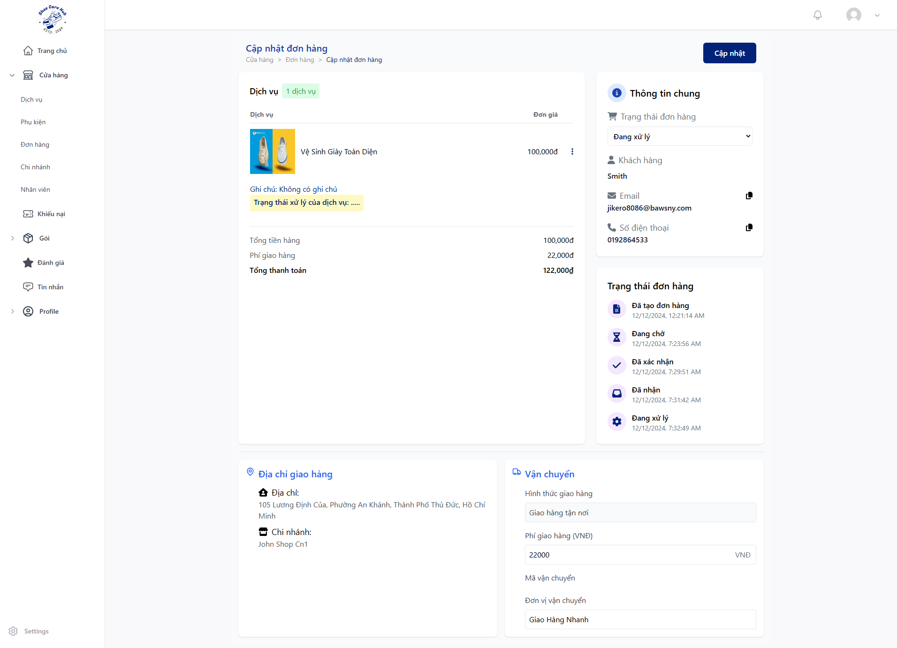
- Click “$⋮$” then “Cập nhập dịch vụ”.
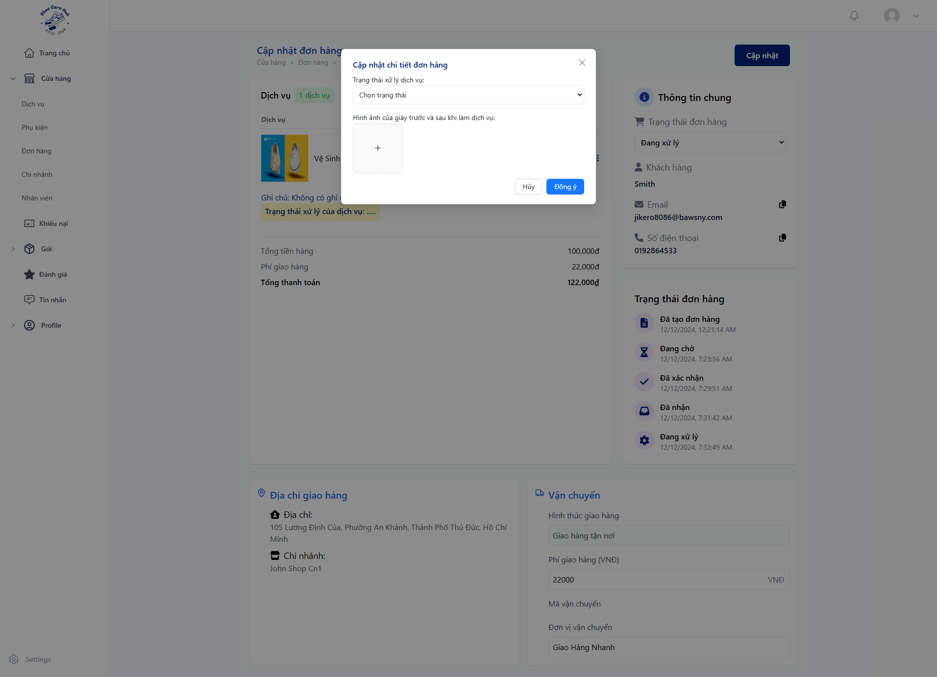
- Update service process at “Trạng thái xử lý dịch vụ”.
- Upload service process image at “Hình ảnh của giày trước và sau khi làm dịch vụ”.
- Click “Đồng ý”.
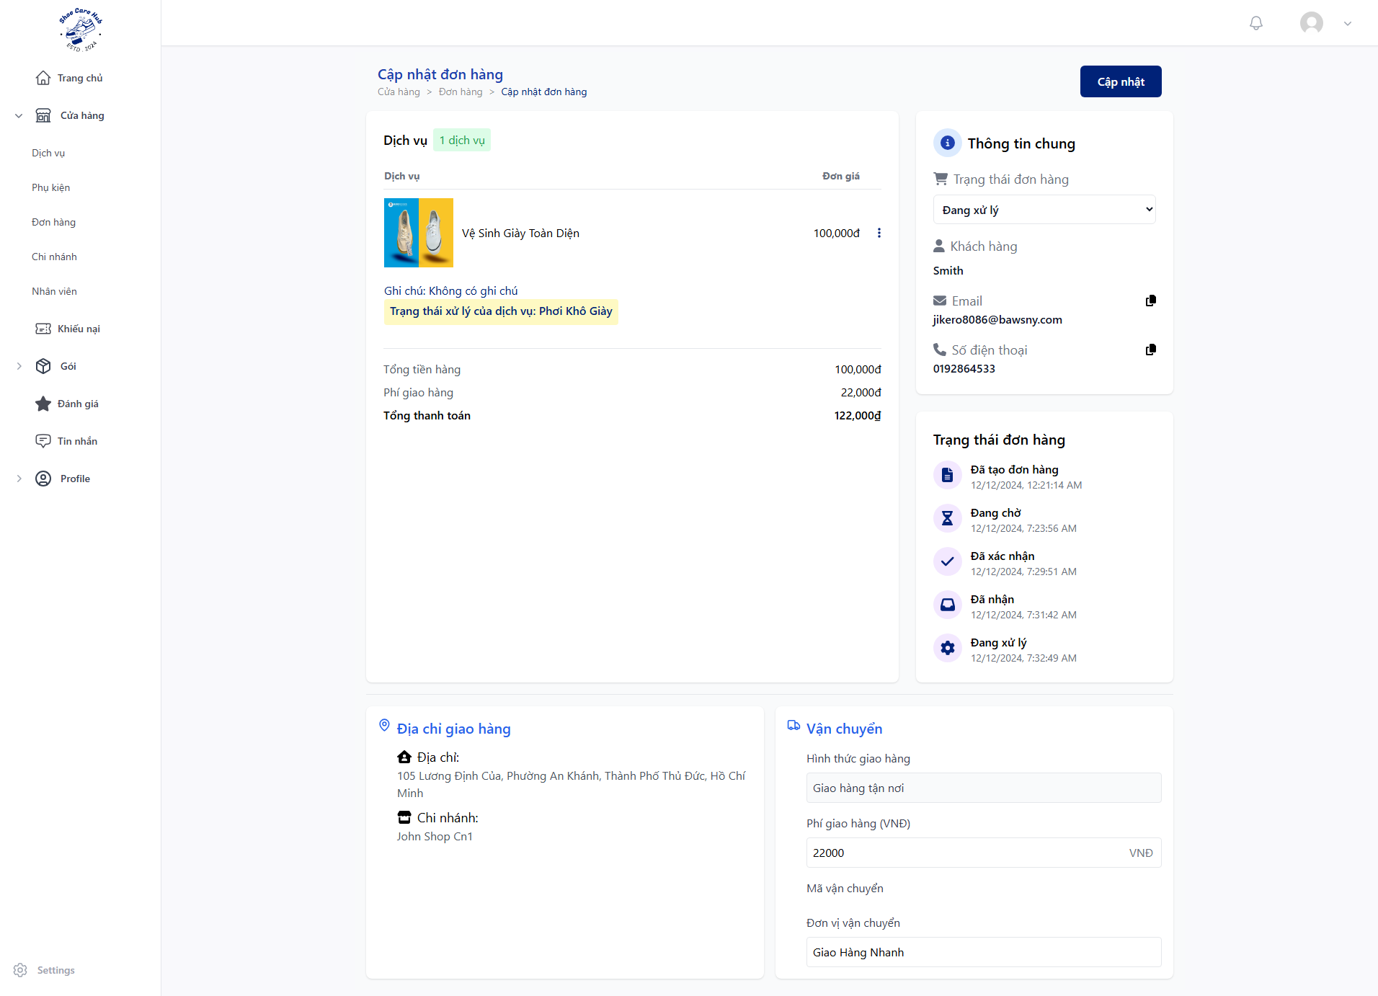
- Click “Trạng thái đơn hàng” and choose “Lưu trữ” and click “Đồng ý” then “Cập nhập”.
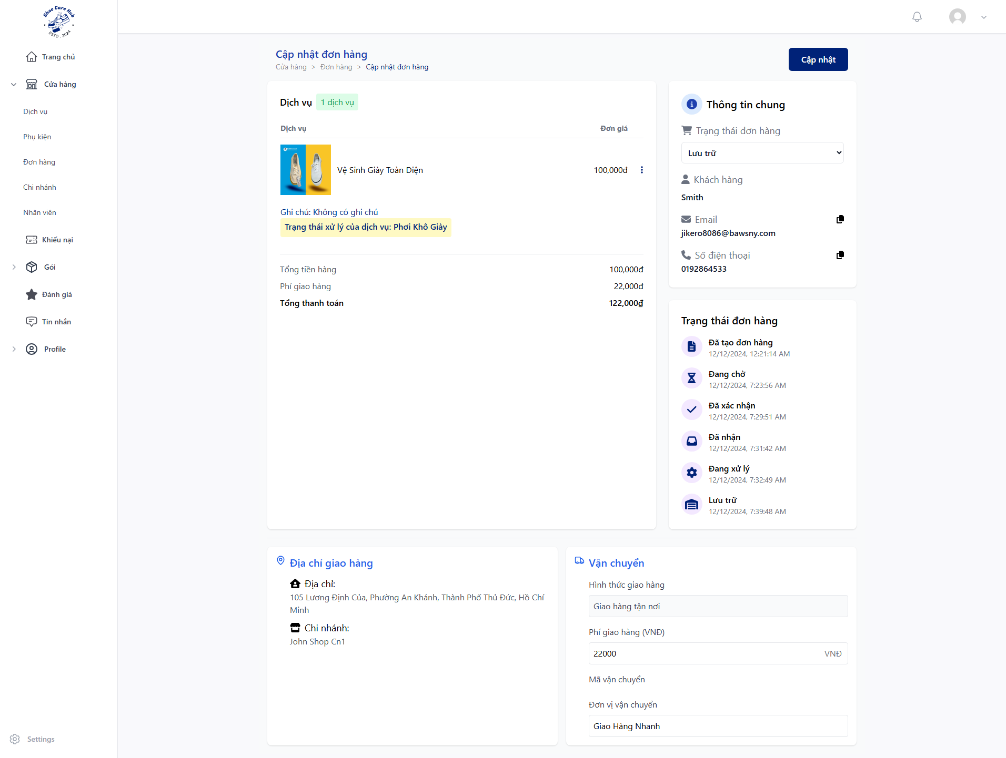
- Click “Trạng thái đơn hàng” and choose “Đang giao hàng” if have to ship, “Đã giao hàng” if take at shop or “Quá hạn nhận giày” if shoe is abandoned and click “Đồng ý” then “Cập nhập”.
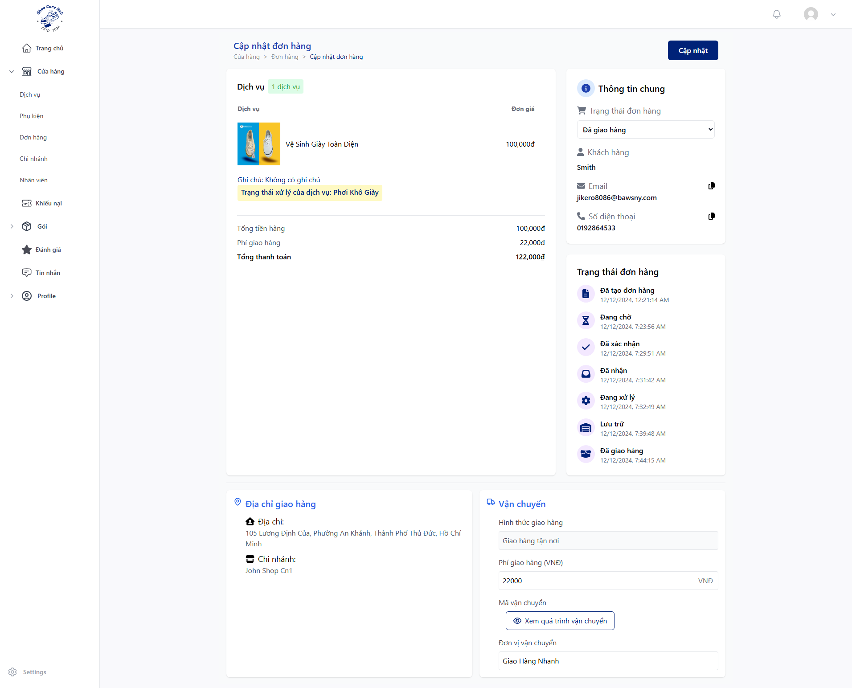
- Click “Trạng thái đơn hàng” and choose “Hoàn Thành” and click “Đồng ý” then “Cập nhập”.

3.3.4 Customer Check Order
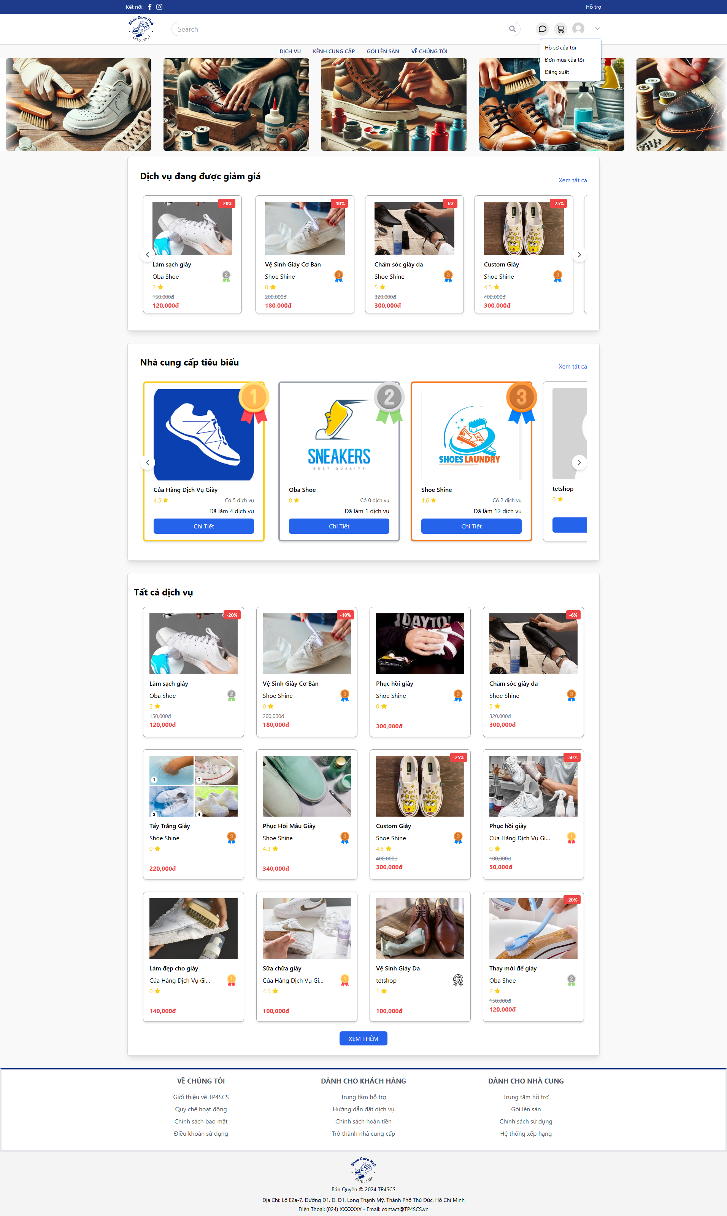
- At Home Page, click avatar icon the click “Đơn mua của tôi”.
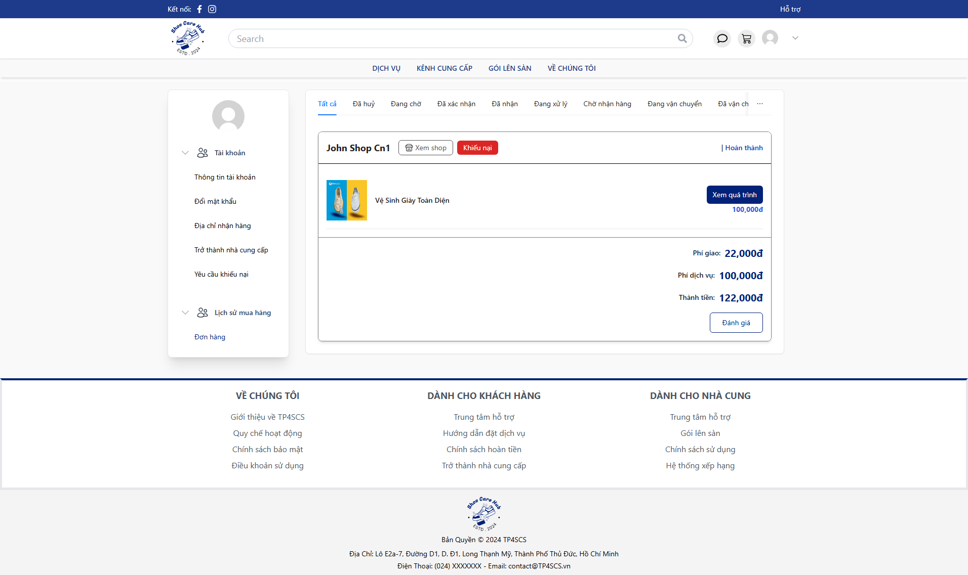

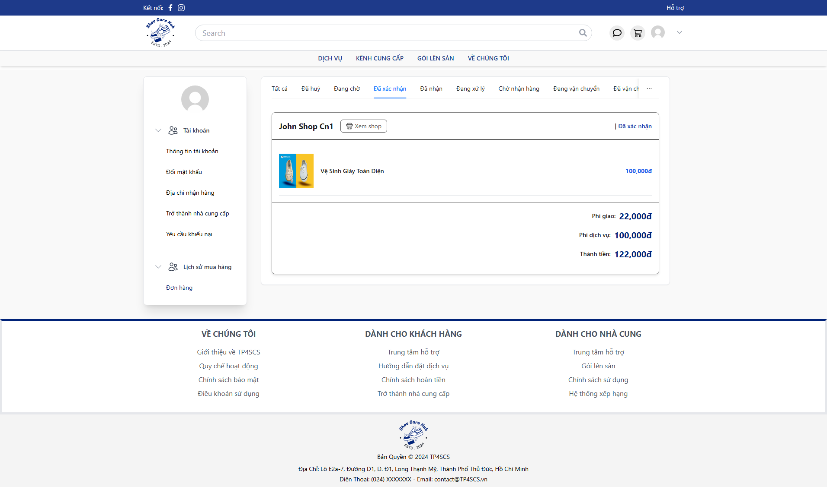
- Click “Đã xác nhận” to view approved order.
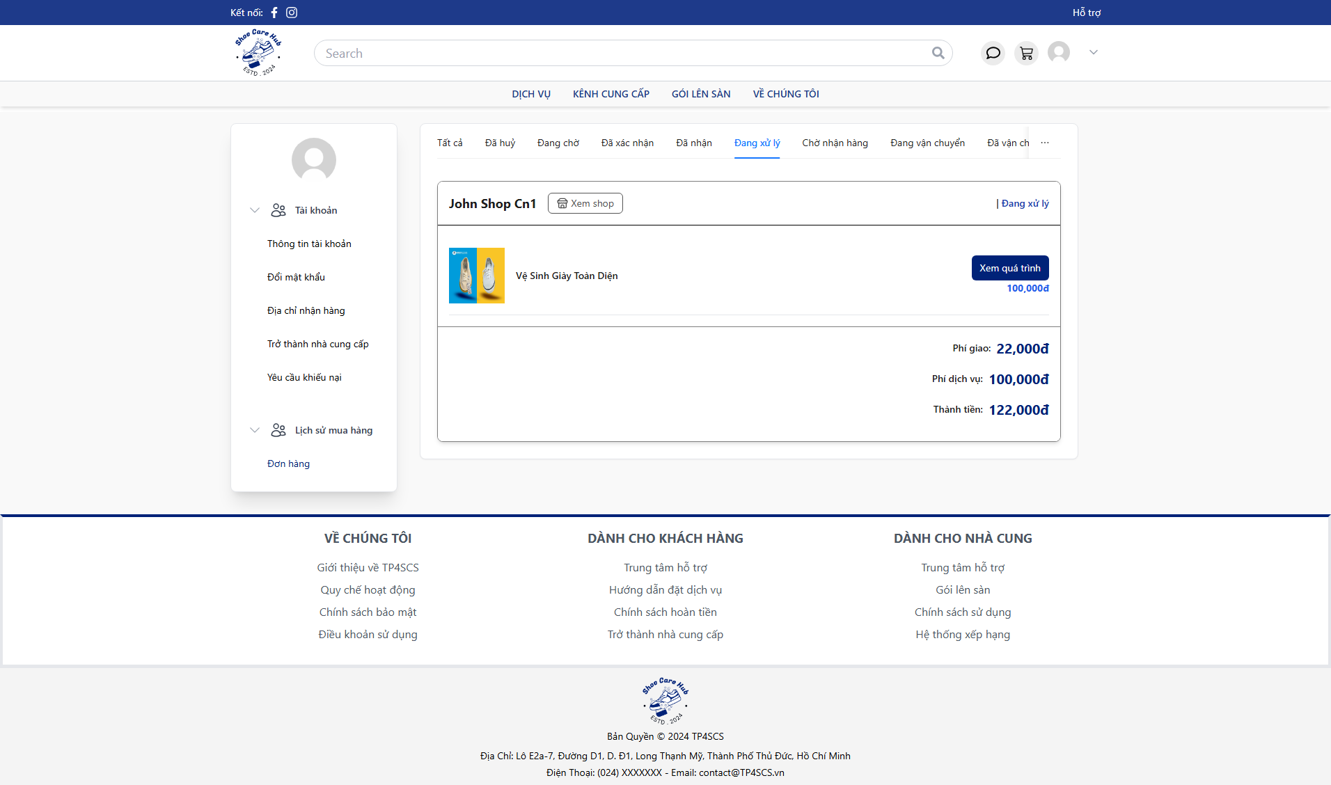
- Click “Đang xử lý” to view processing order.
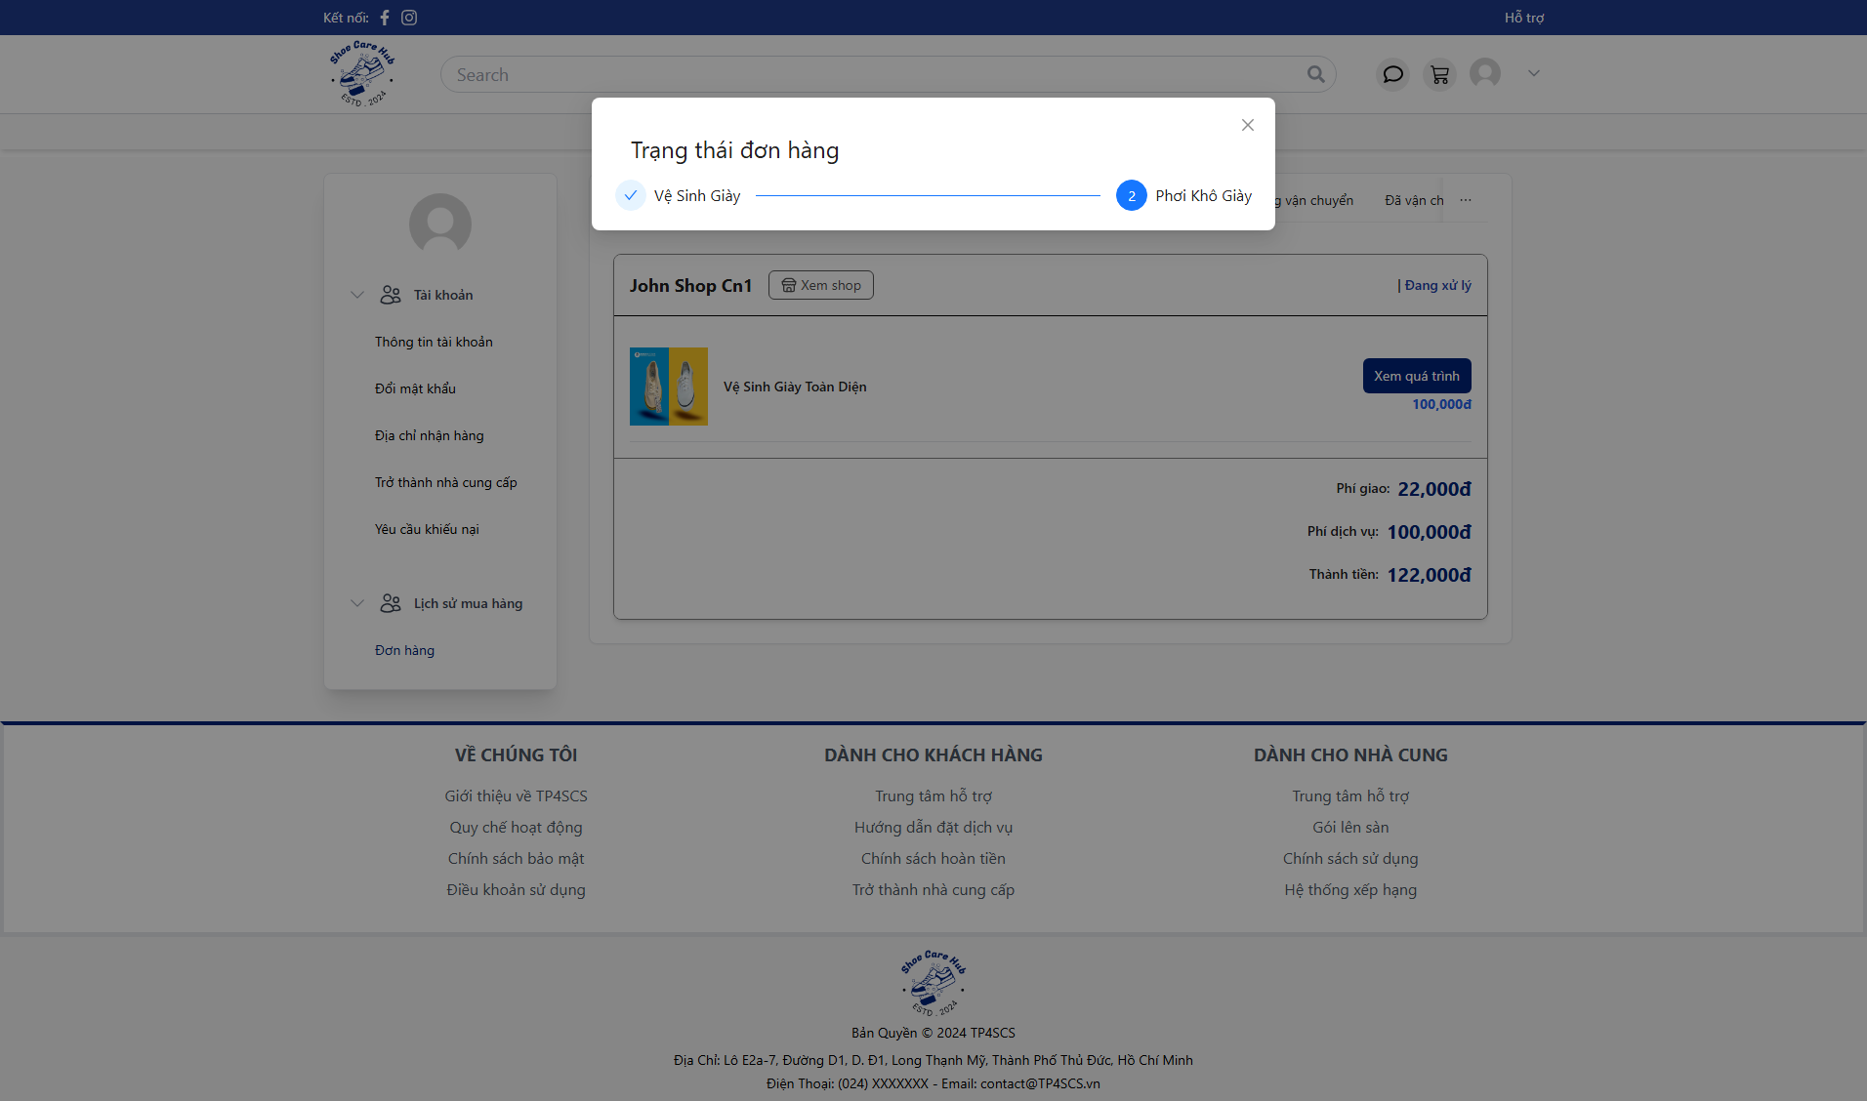
- Click “Xem quá trình” to view order process state.
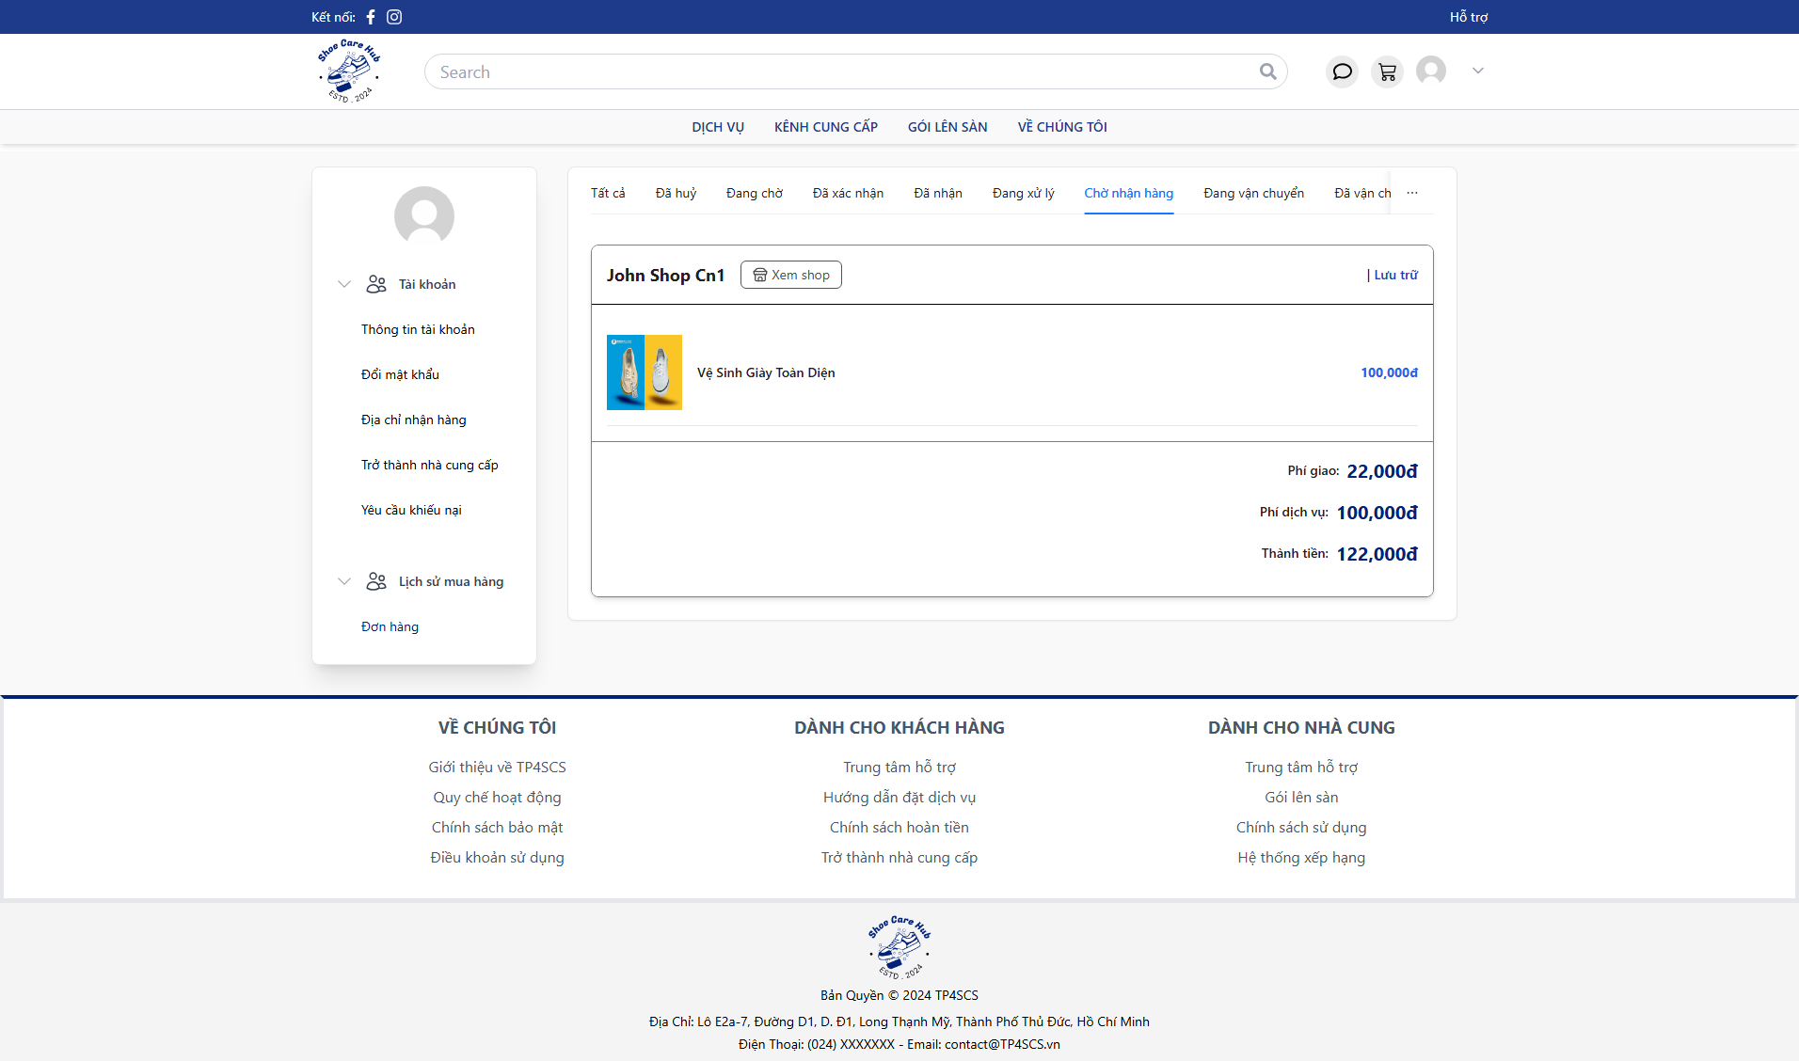
- Click “Chờ nhận hàng” to view storage order after finish process.
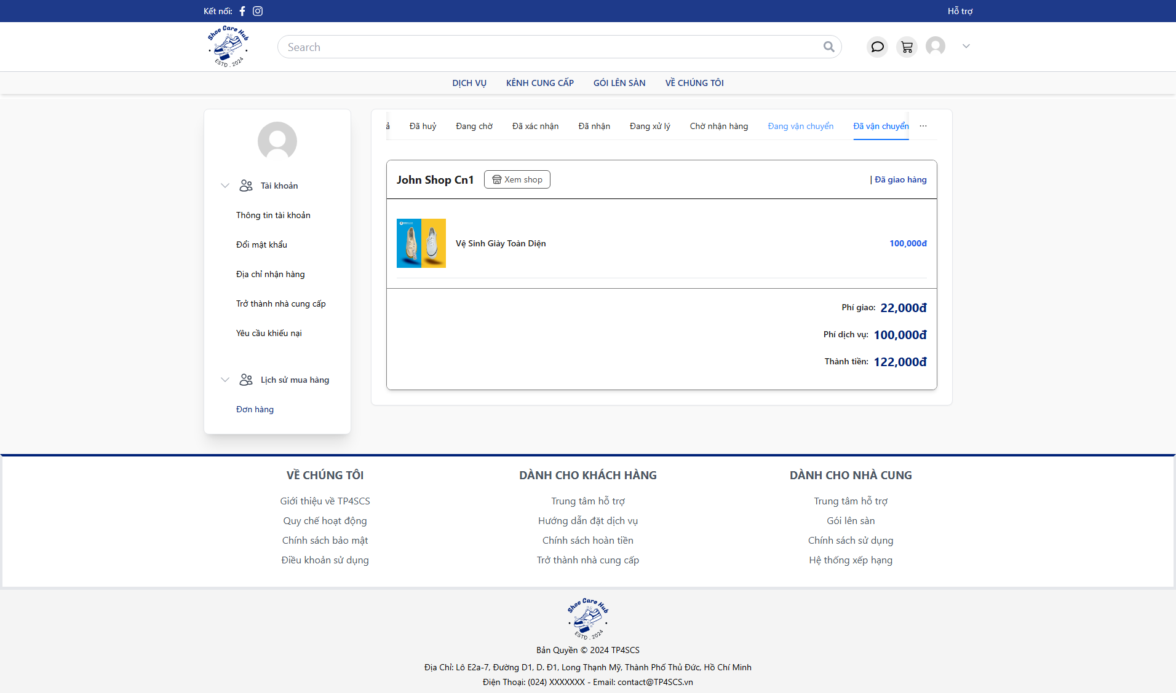
- Click “Đã vận chuyển” to view shipped order.

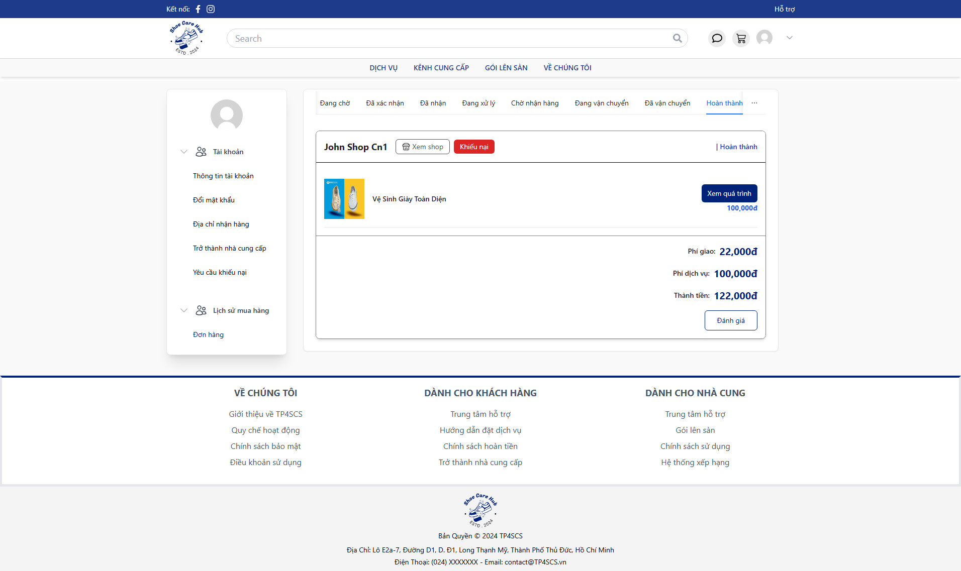
- Click “Hoàn thành” to view finished order.

3.4 Process Support Ticket Flow

3.4.1 Customer Create Ticket

- At Home Page, click avatar icon the click “Hồ sơ của tôi”.
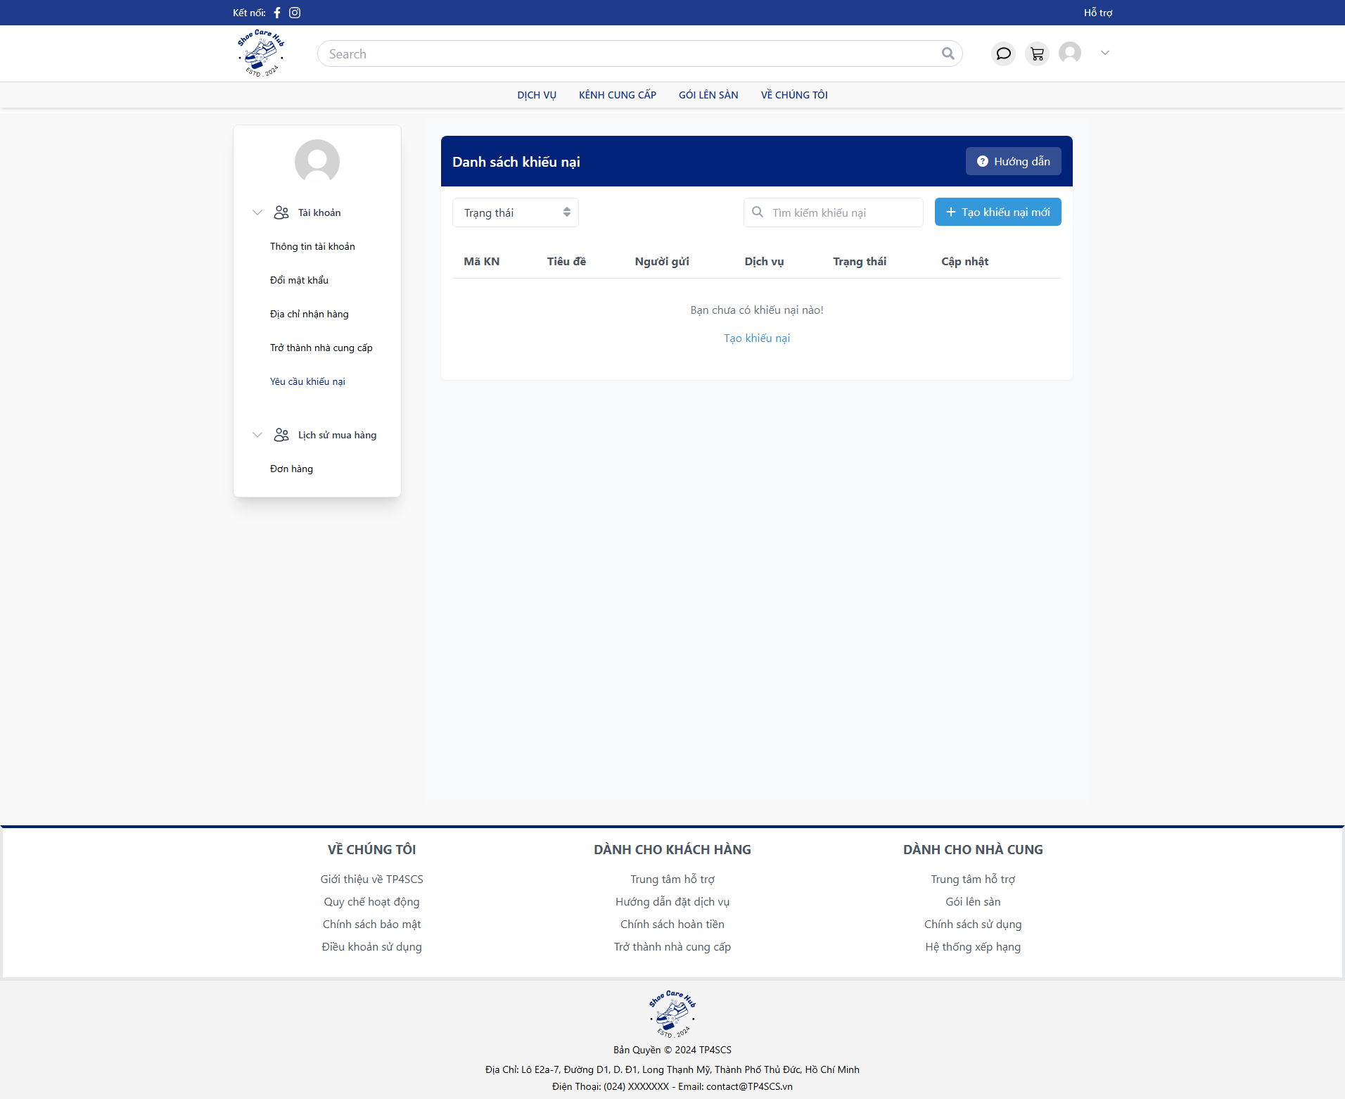
- Click “Yêu cầu khiếu nại” then click “Tạo khiếu nại mới”.
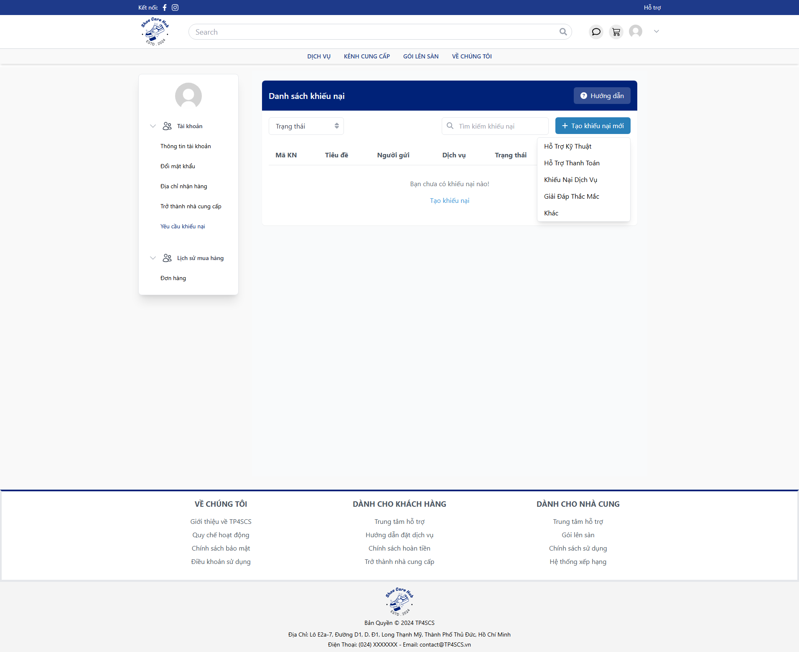
- Choose ticket category.
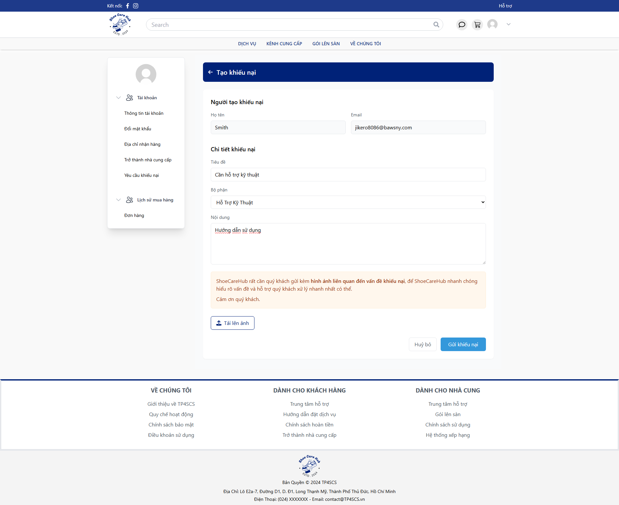
- Fill all require fields with valid data then click “Gửi khiếu nại”.
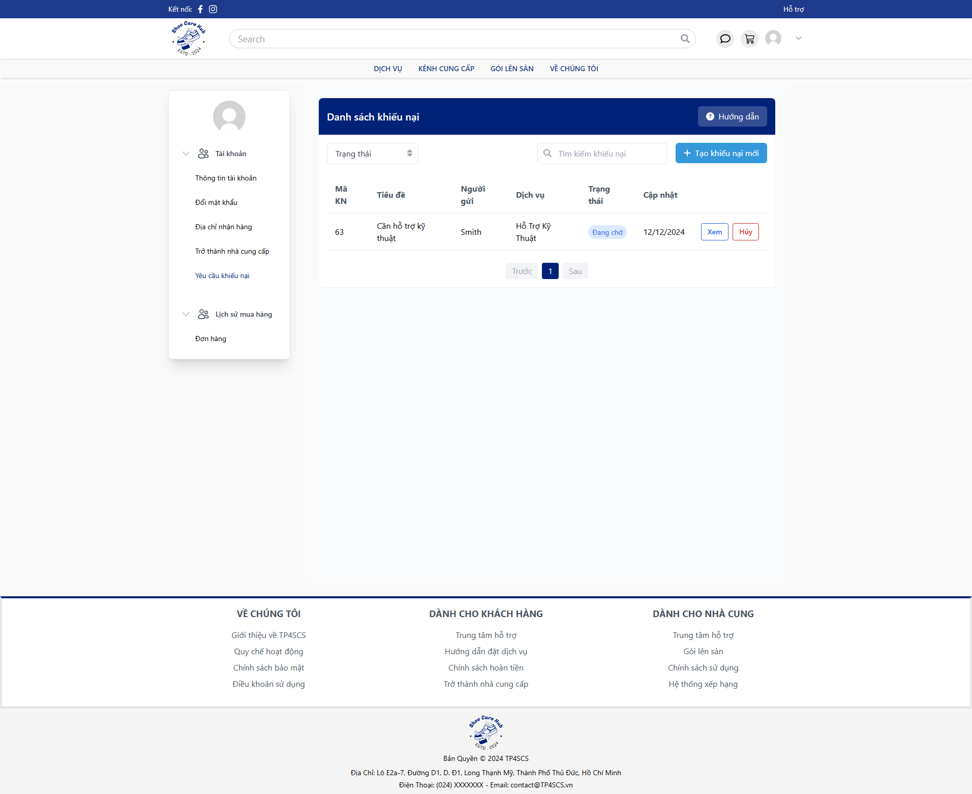
- After create can view the ticket detail by click “Xem” or cancel ticket by click “Huỷ”.

3.4.2 Moderator Process Ticket
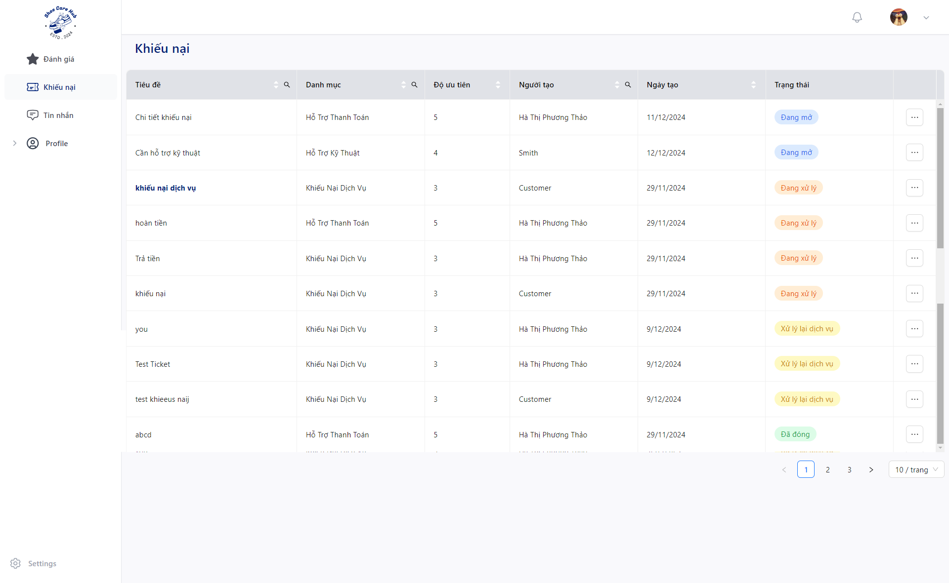
Click “Khiếu nại” and click “” to specific ticket then click “Cập nhập”.
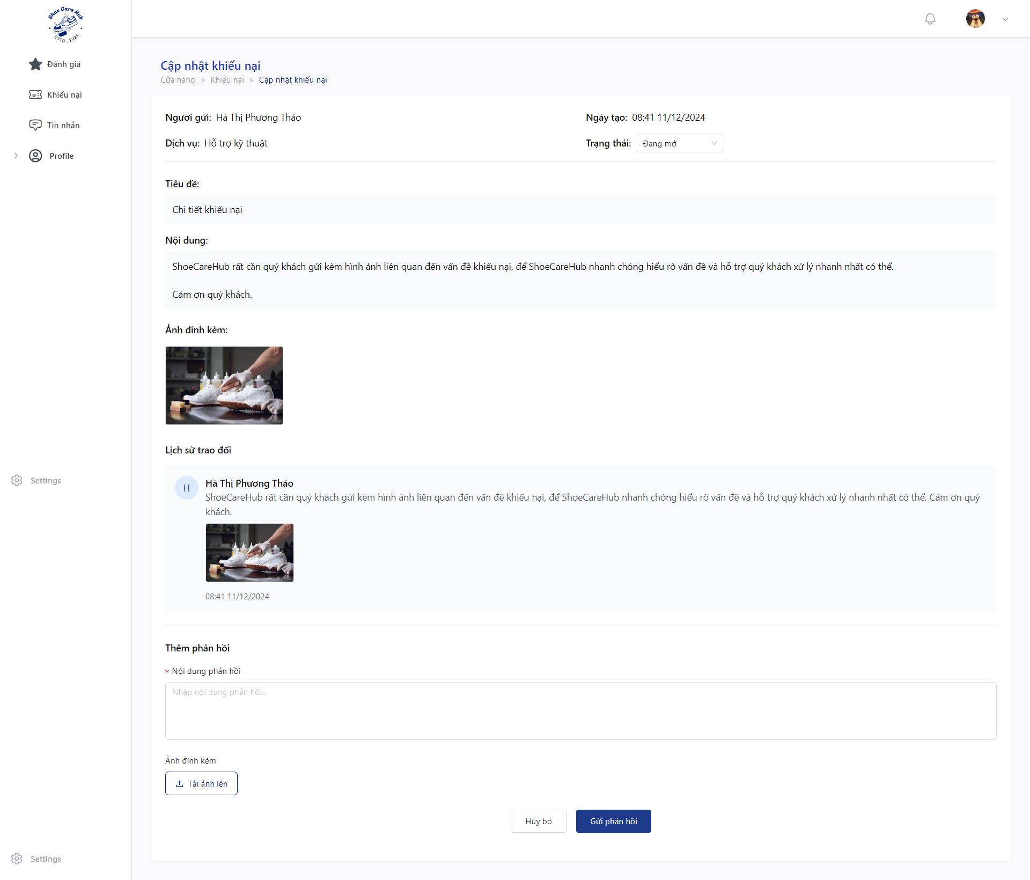
- Click “Trạng thái” and choose “Đang xử lý” the click “Đồng ý” to process the ticket.

- Fill valid data at “Nội dung phản hồi” for response ticket.
- Click “Tải ảnh lên” to upload asset for the response.
- Click “Gửi phản hồi” to send ticket response.
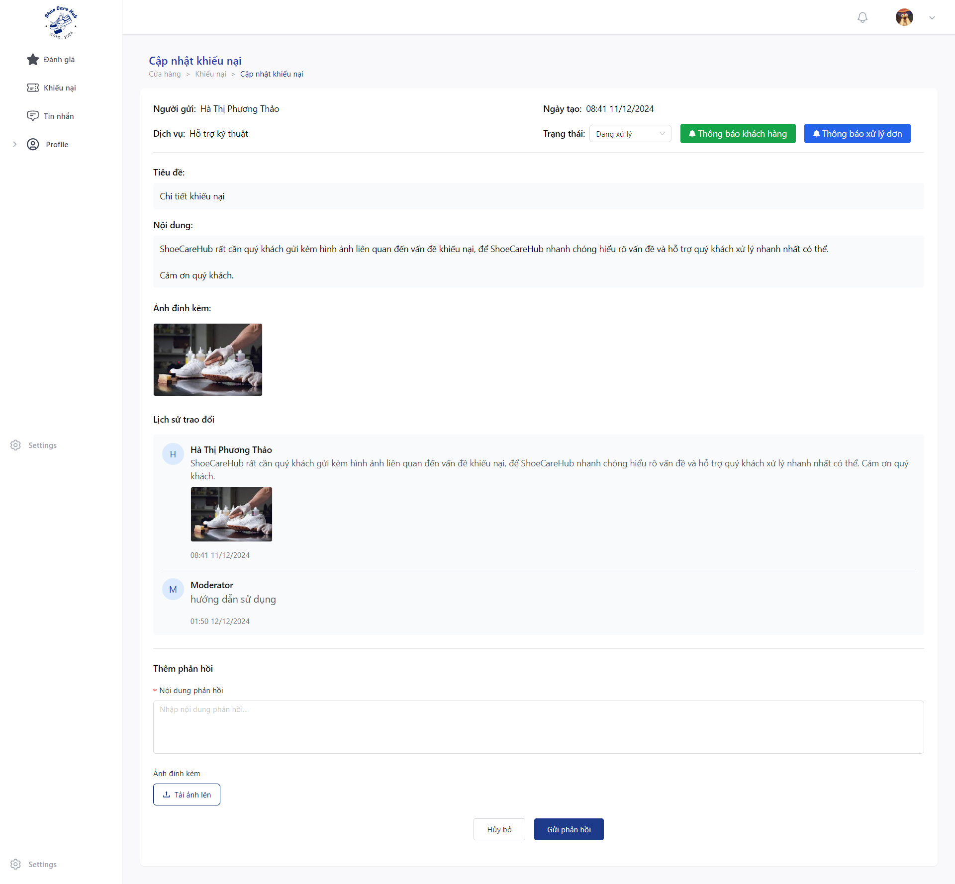
- Click “Thông báo cho khách hàng” to send email notification for customer before close.
- Click “Trạng thái” and choose “Đống” the click “Đồng ý” to close the ticket.
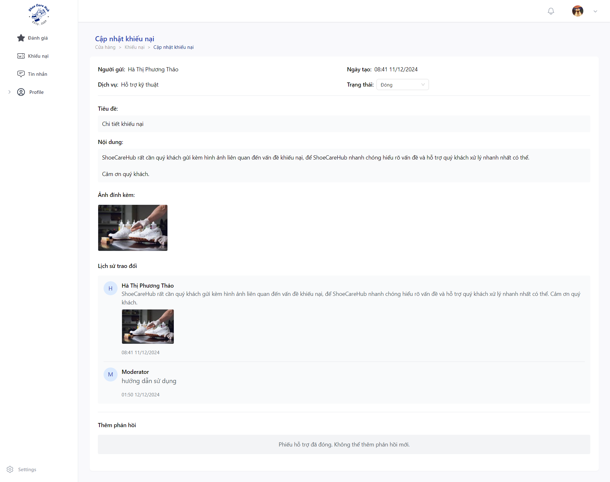

3.4.3 Customer Check Ticket
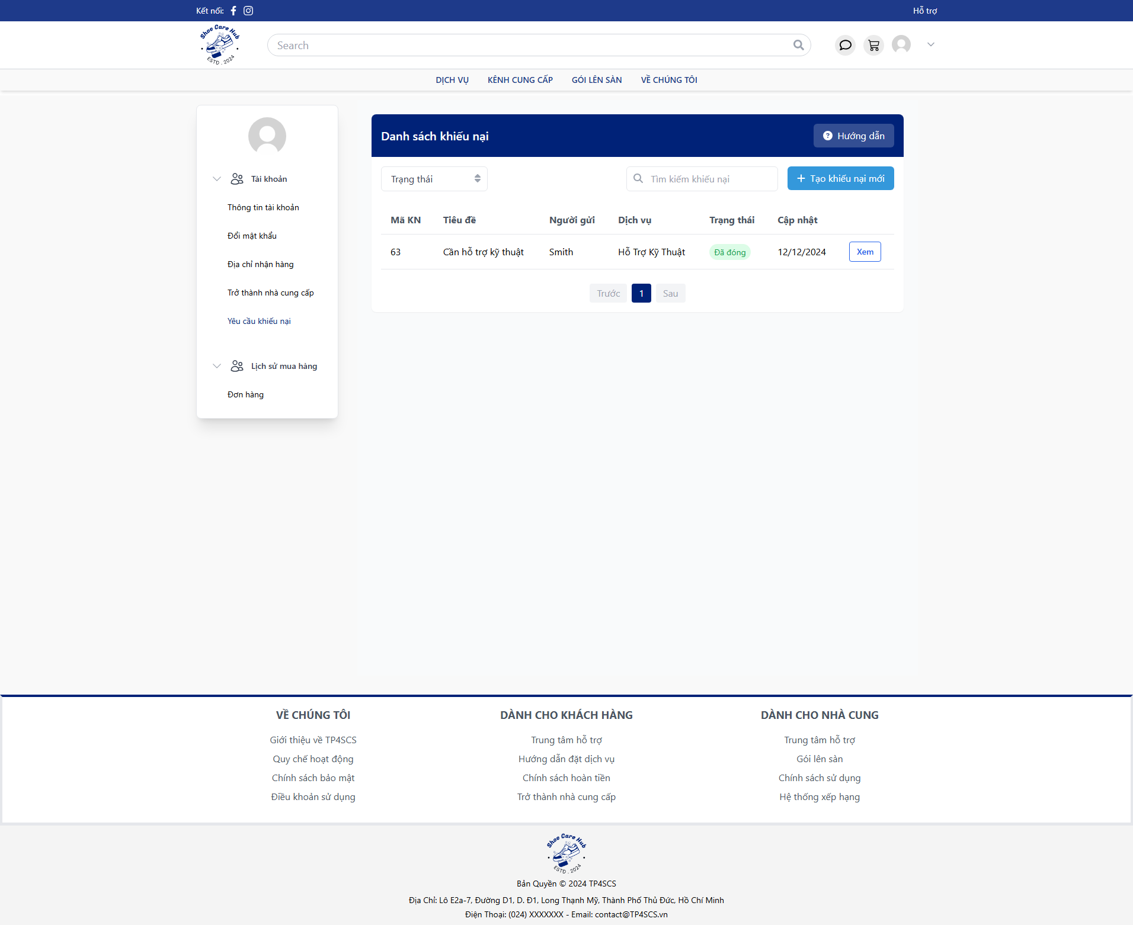
- Go to “Yêu cầu khiếu nại” then click to “Xem”.
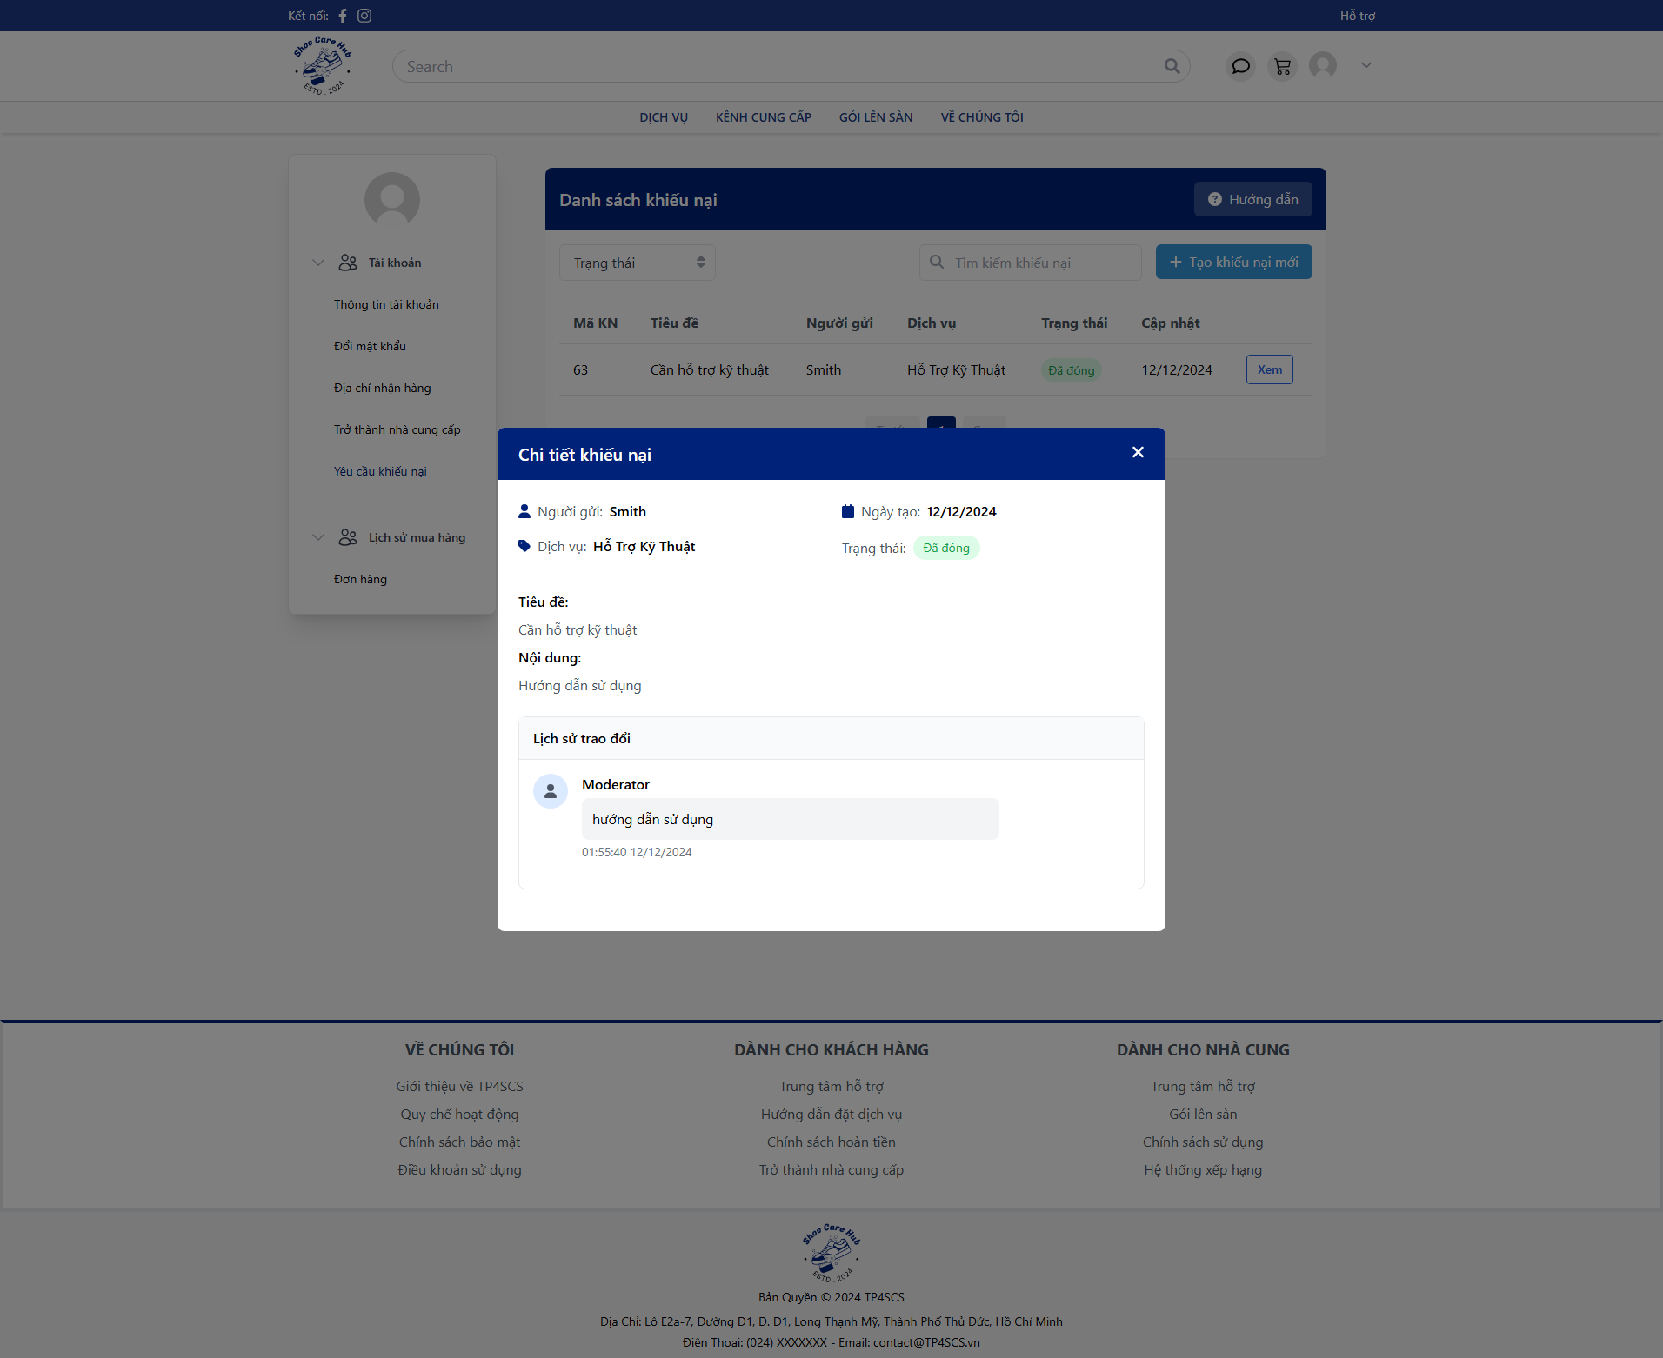

3.5 Feedback Flow

3.5.1 Customer Create Feedback

- Go to “Đơn mua của tôi” then choose finished order by click “Hoàn thành”.
- Click “Đánh giá” to create new feedback.
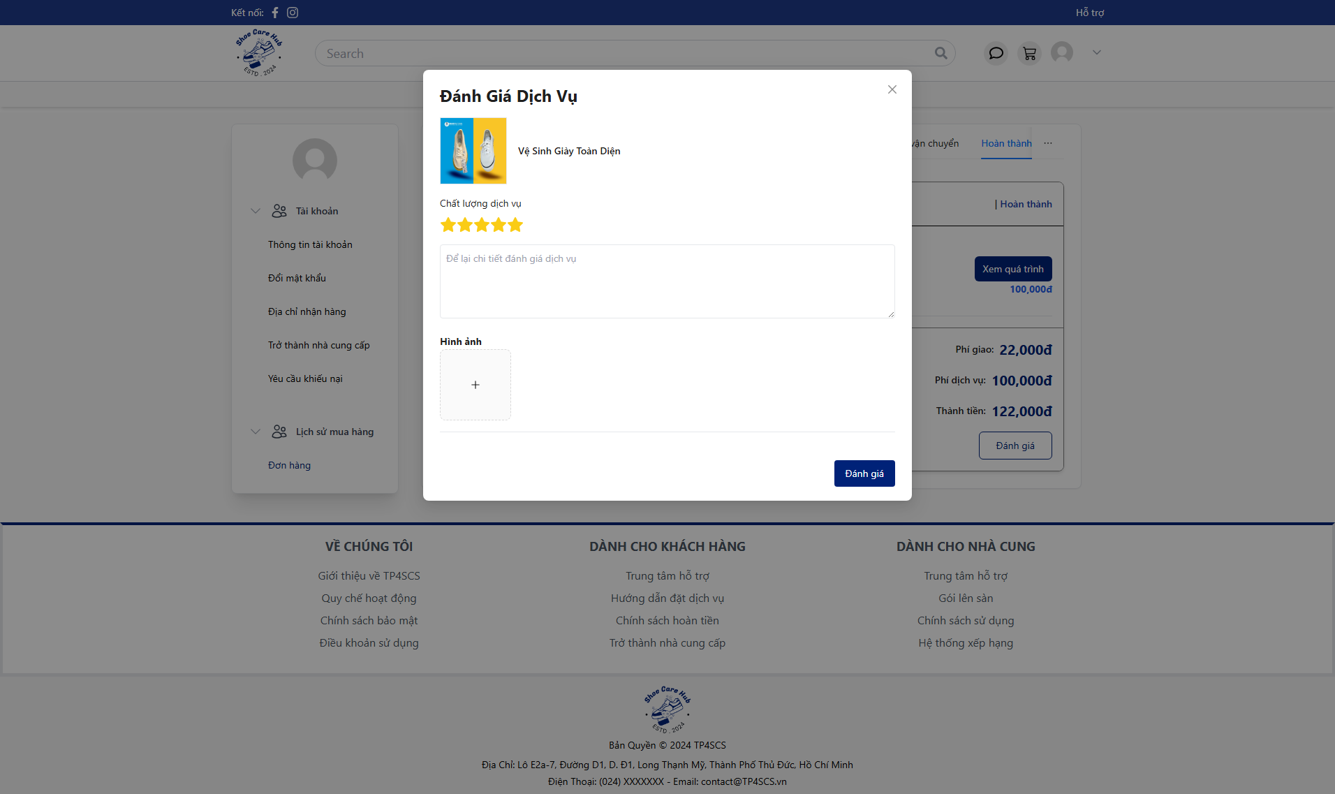
- Fill all feedback fields with valid data then click “Đánh giá”.

3.5.2 Moderator Validate Feedback
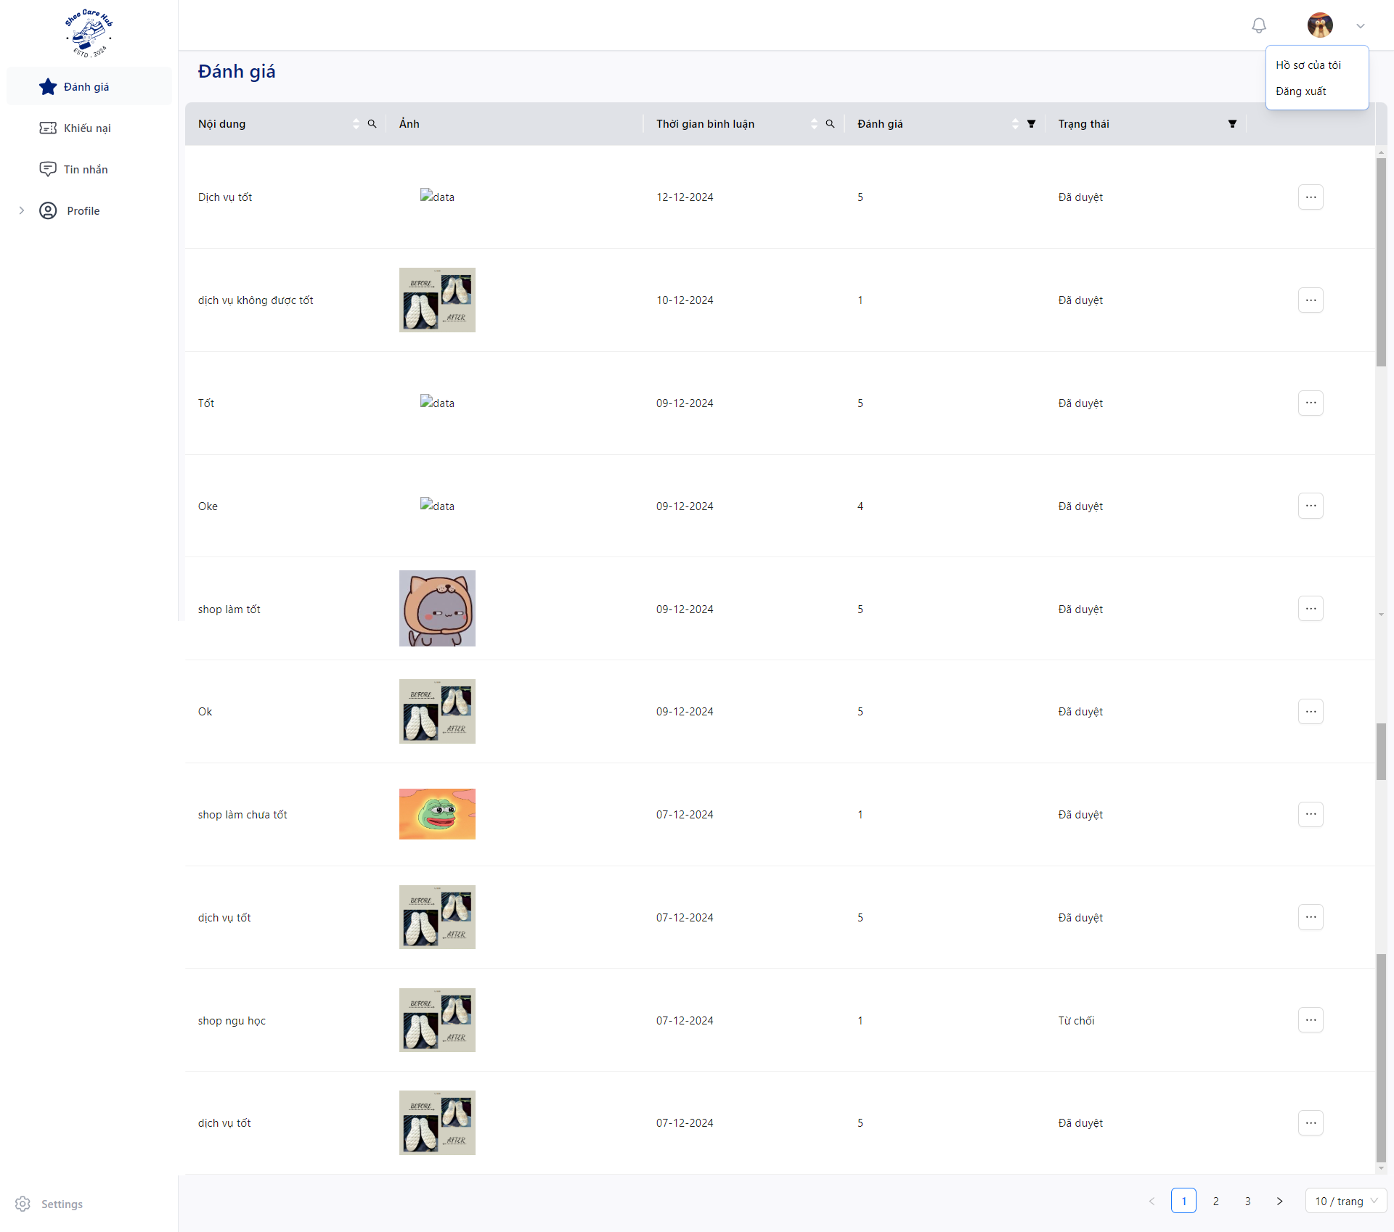
- Click to “Đánh giá” and click “” to specific feedback then click “Cập nhập”.
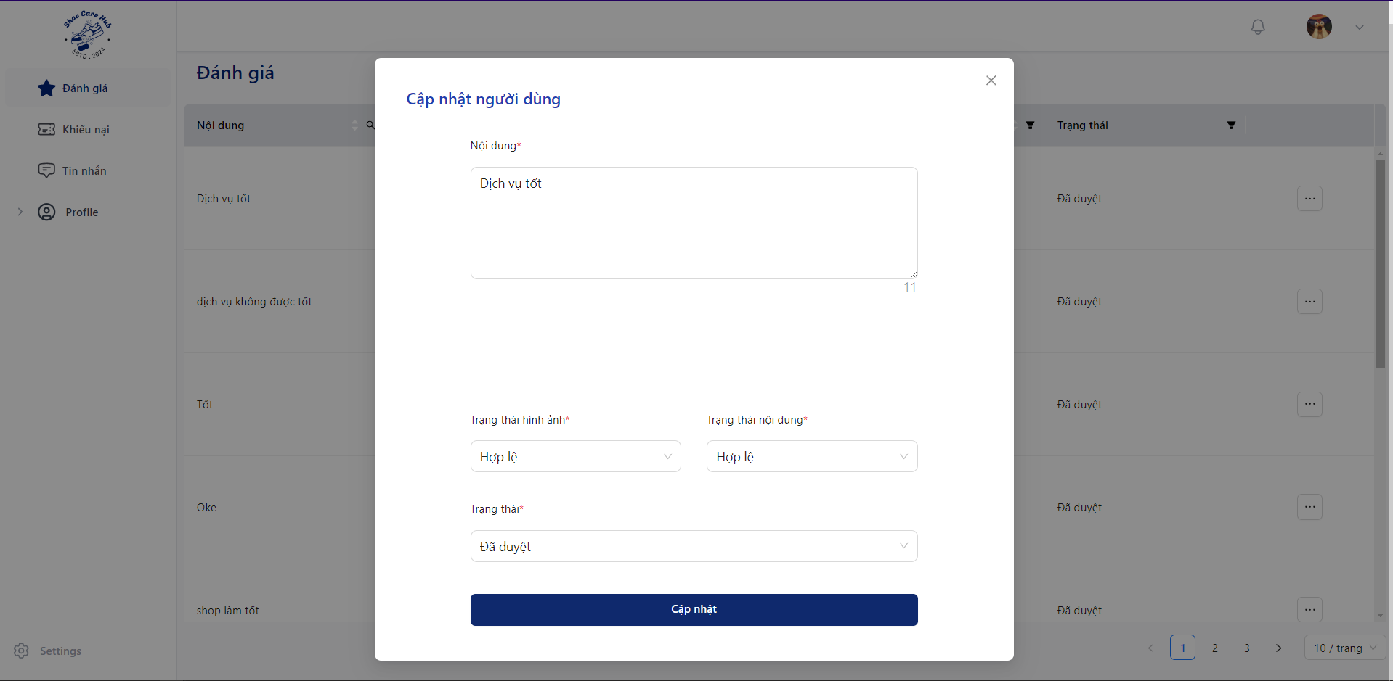
- Check feedback content.
- Choose status at “Trạng thái hình ảnh”: “Hợp lệ” for valid content, “Không hợp lệ” for invalid content.
- Choose status at “Trạng thái nội dung”: “Hợp lệ” for valid content, “Không hợp lệ” for invalid content.
- Click “Cập nhập” to validate feedback.

3.5.4 Customer Check Feedback
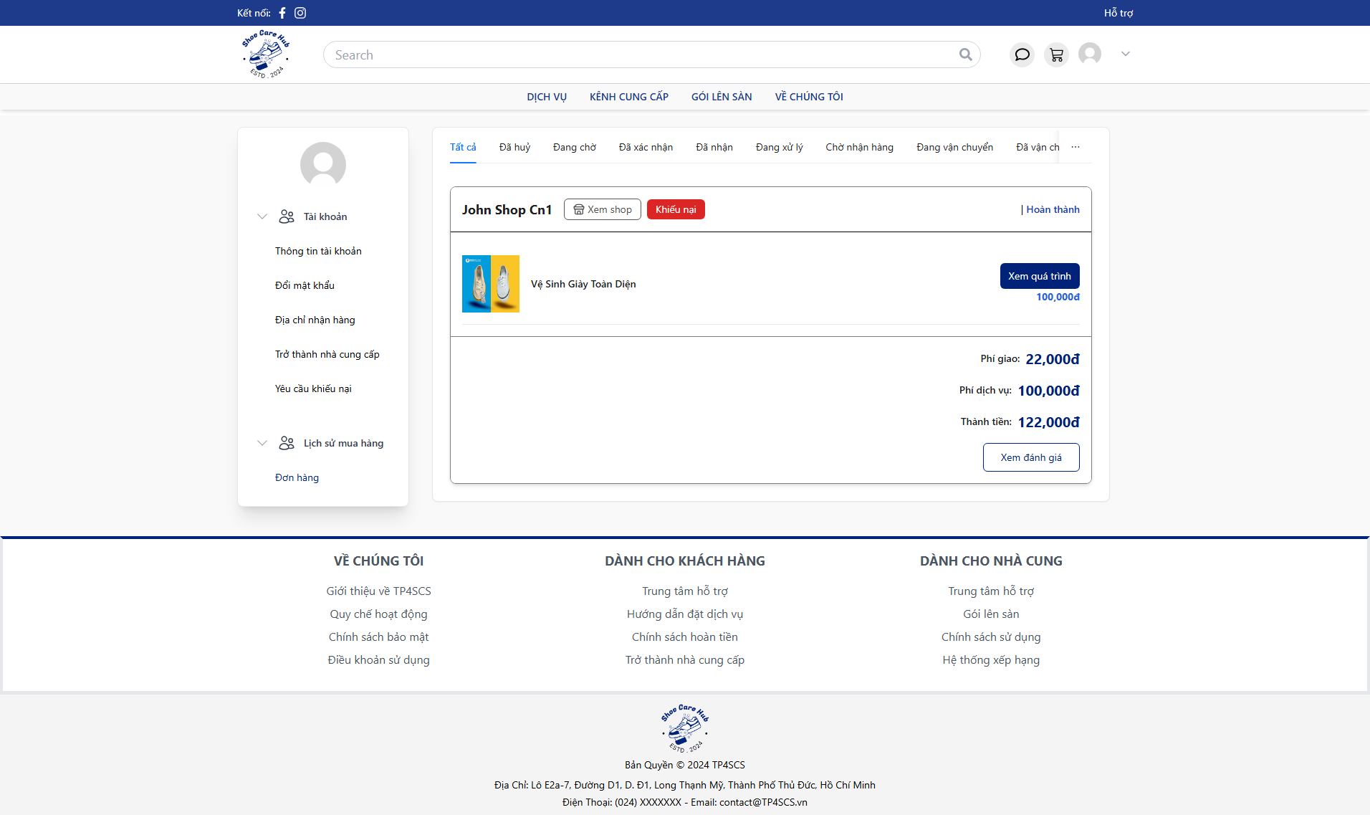
- Click “Xem đánh giá” to view the feedback validate result.
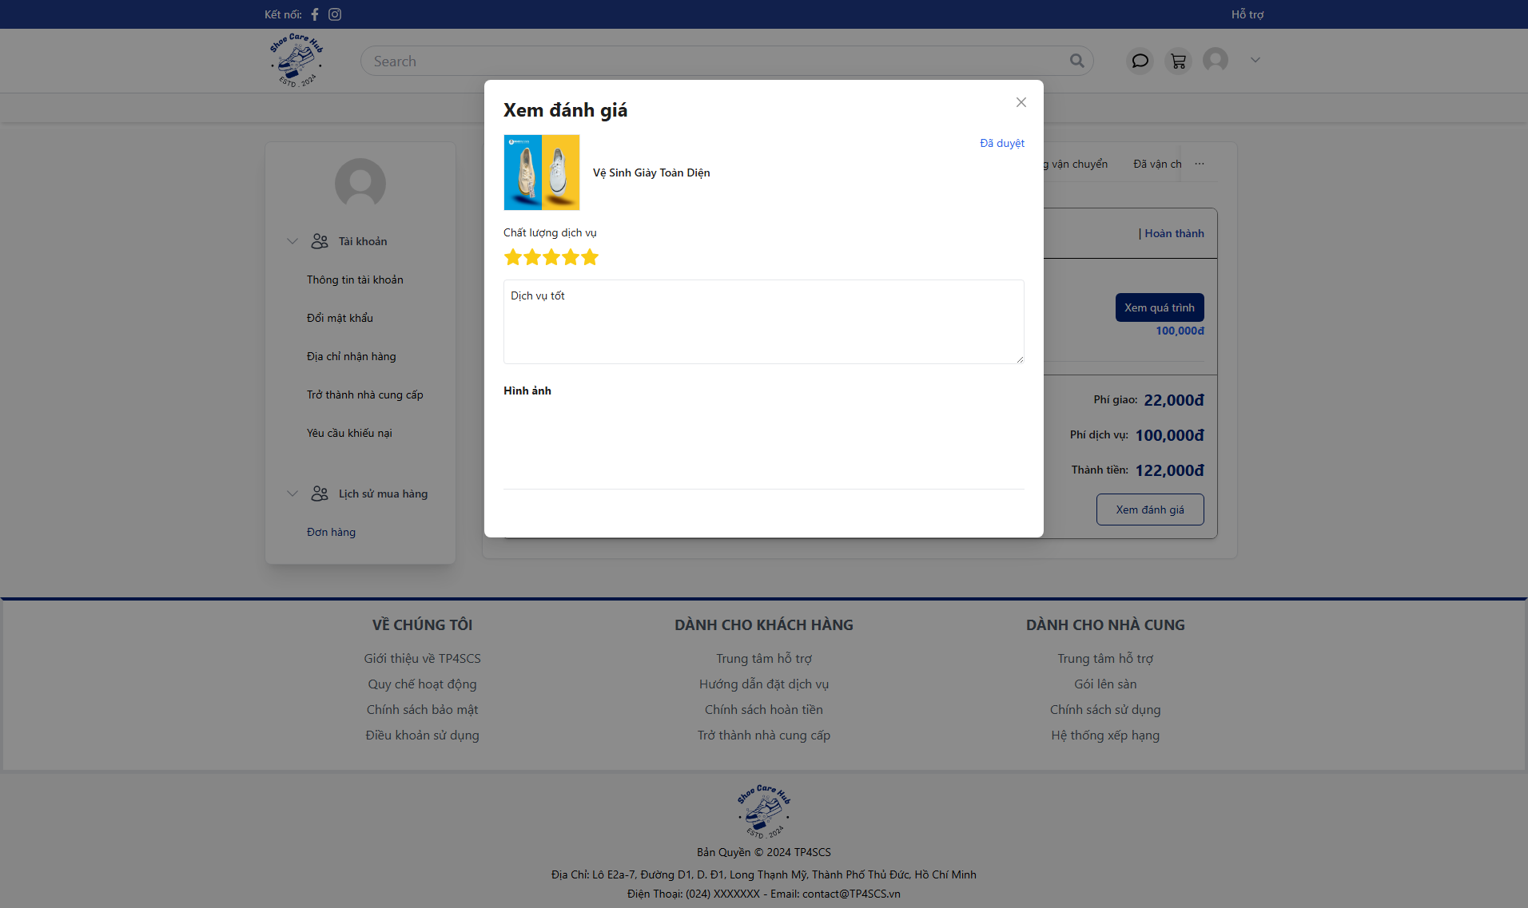

3.5.3 Owner Reply Feedback
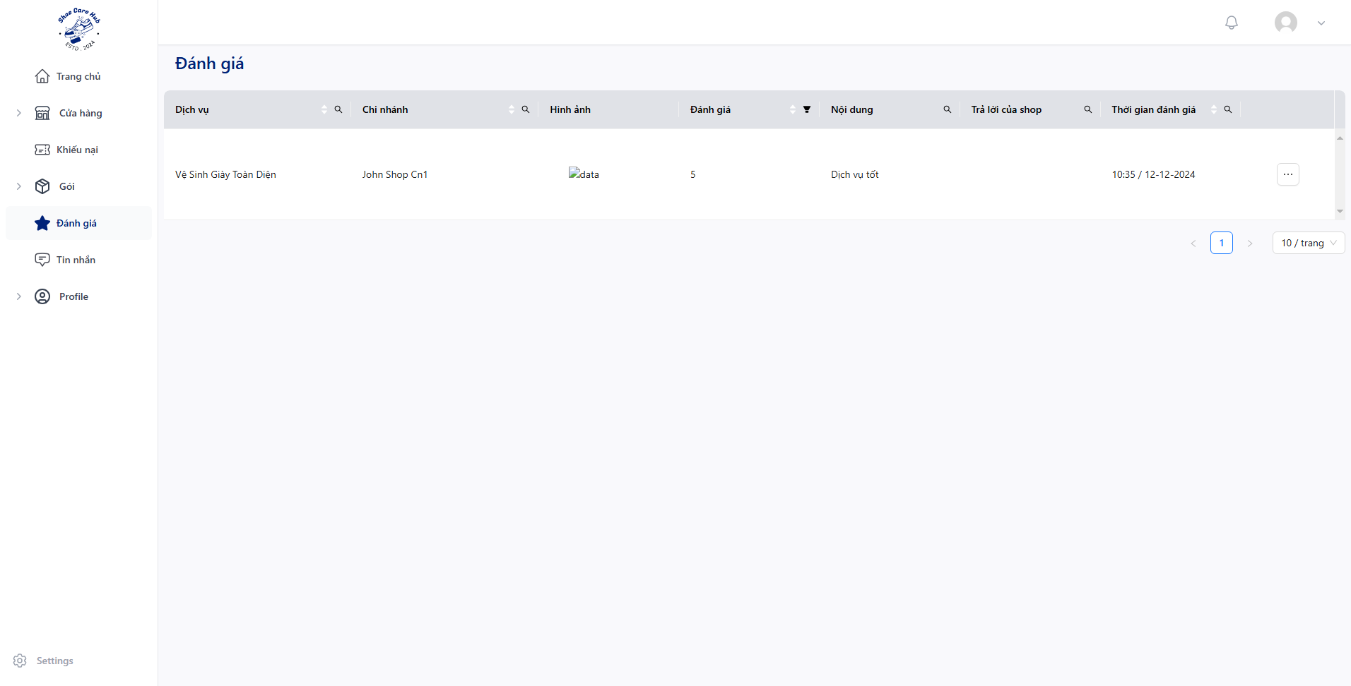
- Click “Đánh giá” to view all business’s feedback and click “” then choose “Chi tiết”.
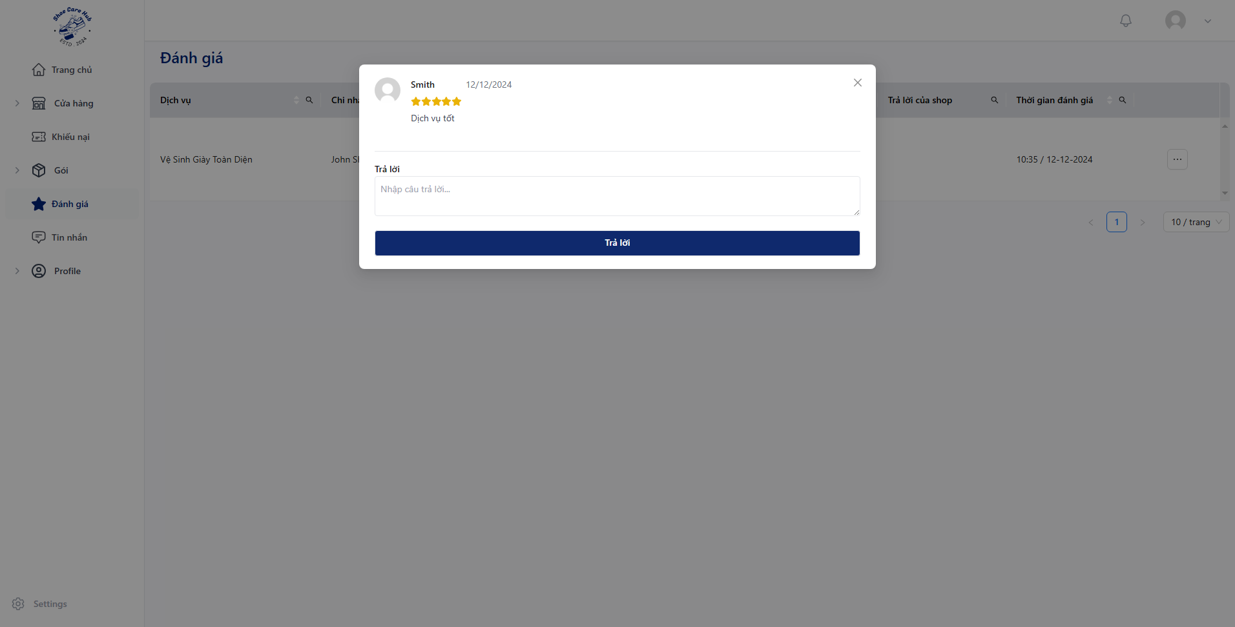
- Fill reply content then click “Trả lời”.

